Powertrain
Motor Selection
Car specifications:
Specification | Details
Mass | 280Kg (Inc. driver)
Frontal Area | 1.0735m2
Distance to Travel | 22km
Time for Endurance Test | 30 mins

Based on the above car specifications, a detailed document of Motor/Controller Calculations is attached for the verification of all data specified here.

Wheel Requirements:
Requirement | Mean | Peak
Power | 12kW | 40kW
Wheel speed | 850 rpm | 1650 rpm
Torque | 132.16 Nm | 227 Nm
Energy | 4.224 kWh | 7.376 kWh

Using a gear ratio of 3:1 as a chain drive gear system could be found in the zip file of Chain-drive system for transmission
Requirement | Mean | Peak
Wheel speed | 2550 rpm | 4950 rpm
Torque | 44.05 Nm | 75.6 Nm
Power | 12kW | 40kW

Ensuring factors like optimal performance and efficiency, a right motor for the use was an indeed necessary decision to be made. The Motor Selection Datasheet, depicts the long selection procedure that includes the comparison of all the motor parameters that may fit our requirement, whose specifications are attached in the following table:

Motenergy ME1905 (ME1507) Brushless 14.5kW Cont. 44kW Pk. IPM Motor 48-120V

Specification | Mean | Peak
Power | 14.5kW | 44kW
Rotor Speed |  | 6000 RPM
Current | 220A AC | 550A AC for 1 min
Torque | 41.8 Nm | 104.5 Nm
Voltage (DC) | 48V Min | 120V max
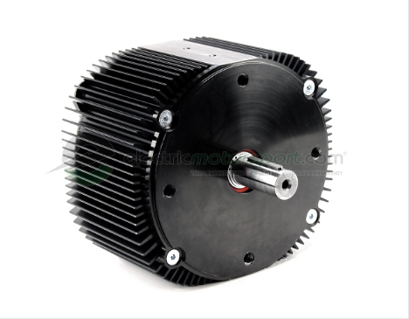
Here is the photo attached for the reference:

Controller Selection

The selection of the motor controller is based on the compatibility of the motor with the driver. The motor controller must satisfy the power requirements of the motor and is able to modulate it according to the driver’s input. The controller that works best with our motor is SEVCON Gen4 Size-6 80V, whose specifications are tabularized below :
Model | Size 6
Nominal Battery Voltage | 96 – 120 VDC
Maximum Operating Voltage | 150 VDC
Minimum Operating Voltage | 48 VDC
Peak Phase Current (2 min) | 550 A
Boost Phase Current (10 sec) | 660 A
Continuous Phase Current (60 min) | 220 A

Controller Manual link is thereafter attached here for referring to manuals and detailed design for the controller, and for the detailed selection procedure, refer to the attached document of Controller Selection.

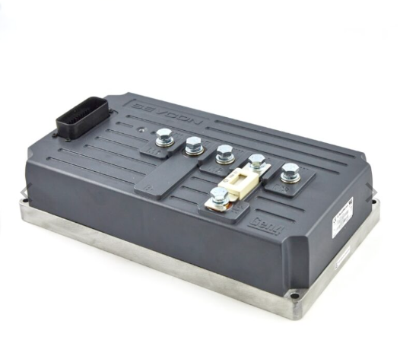

Matlab Simulink model of the motor driver
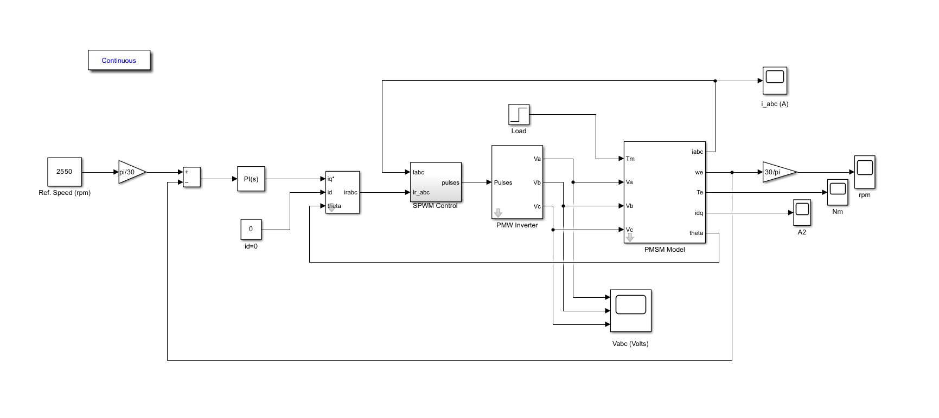

The model is simulated with the following motor specifications; R=0.0025; Ld=0.0066; Lq=0.0058; Yaf=0.1546; P=6; J=0.00176; B=0.00038818; Vdc= 120V, Tm=32 N-m, Ref.speed= 2500 Rpm, as maximum power is around this range. At 0.025 sec a load torque of 32 Nm is applied to the motor, which causes a slight decrease in the speed. Initially the commanded torque is equal to maximum capability of the motor and when loaded the electrical torque increases to satisfy the desired load torque.

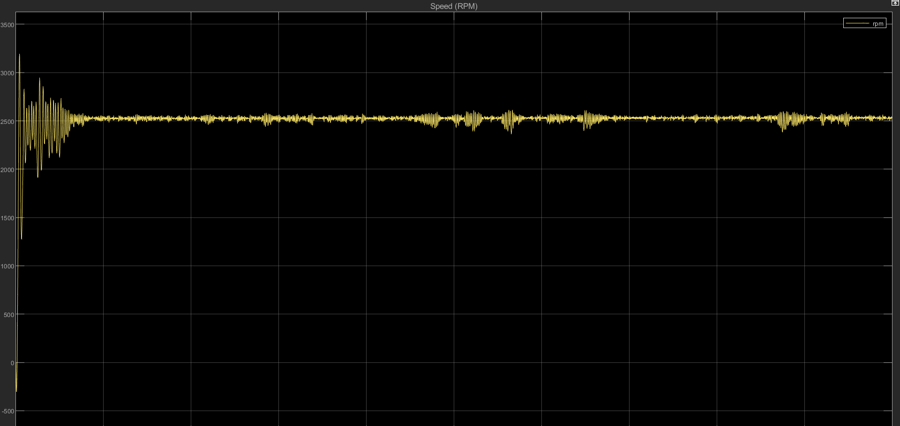
Reference Speed 2500 rpm is maintained


Torque is modulated to maintain the speed
For more simulation results, refer to the document of results of simulink motordrive.
Motor/Controller Thermal Calculations

The Motor/Controller thermal calculation were done by following the below table-summarized parameters:
Parameters | Value
Mass of the Motor (m) | 21.4 kg
Specific Heat Capacity (c) | 500 J/kg·°C
Temperature Difference (ΔT) | 115°C (140°C - 25°C)
Surface Area of the Motor (A) | 0.7035 m²
Heat Transfer Coefficient (h) | 500 W/m²·°C (for Water Cooling)

By using the above parameters the calculations results comes in the following table:
Parameters to be calculated | Result
Heat Energy to be Dissipated (Q) | 1,230,500 J
Heat Transfer Rate (Q) | 40,250 W
Cooling Time (t) | 30.571 s

The designing of the pipe is done by the following values of the parameters:
Parameters | Value
Length | 20 cm
Width | 30 cm
Dia of pipe | 9 mm

The following parameters were used to simulate the model of liquid cooling of motor:
Parameters | Value
Temperature of liquid | 423 K (inlet)
Liquid type | Water
Wall heat conduction coefficient | 500 W/m2/k
Outlet temperature | 292K

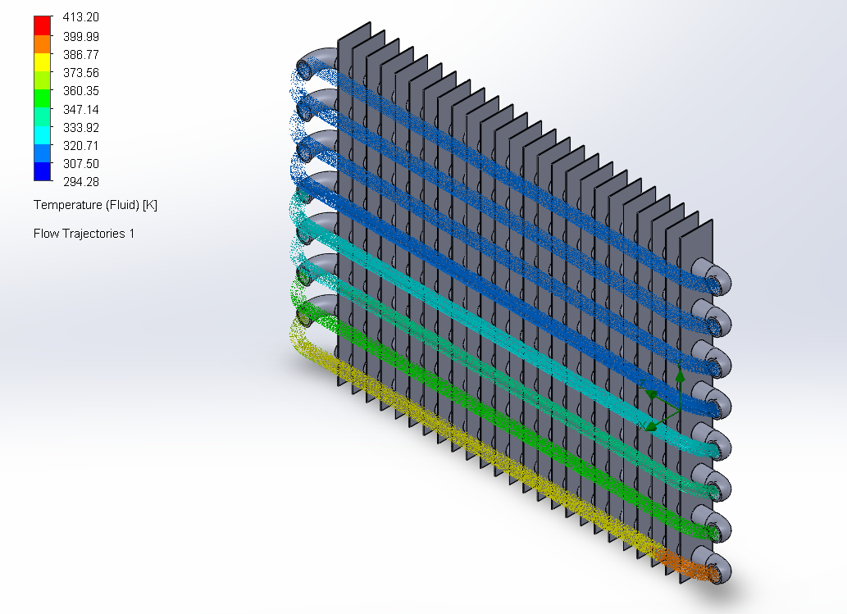
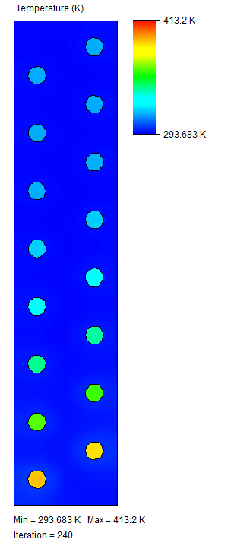
Side view of radiator Demonstration of the fluid temperature inside radiator

Get more details about the calculations and simulation of Motor/Controller in the Motor/Controller Thermal Calculations.

Electronics and Sensors
Brake Pedal Sensor
For the Brake pedal sensor we will be using Honeywell MLH03KPSL01A sensor.
The Honeywell MLH datasheet depicts the long selection procedure that includes the comparison of all the motor parameters that may fit our requirement, whose specifications are attached in the following table:
S no. | Specification | Range
1. | Supply Voltage | 6V to 24V
2. | Output Voltage | 0.5V to 5V
3. | Operating Temperature | -40 C to 125 C
4. | Pressure range | 0 to 3000 psi
Current Sensor
For the Current sensor we will be using LEM CAB-SF 500-C current sensor.
The LEM CAB-SF 500-C datasheet depicts the long selection procedure that includes the comparison of all the motor parameters that may fit our requirement, whose specifications are attached in the following table:
S no. | Specification | Range
1. | Supply Voltage | 8.5V to 16V
2. | Output Type | CAN signal
3. | Operating Temperature | -40 C to 85 C
4. | Nominal current | 500 A
Brake System Plausibility Device:
BSPD is a standalone, non-programmable circuit designed in accordance with FSAE regulations. It is a safety device to prevent potential injury due to the drifting of the electric vehicle. The aim of BSPD is to activate(open) the shutdown circuit (safety circuit) when two conditions are met simultaneously:
• Power Delivered to the motor >= 5KW,
• Hard Braking, if the pressure in brake pedal line > 30 bar.

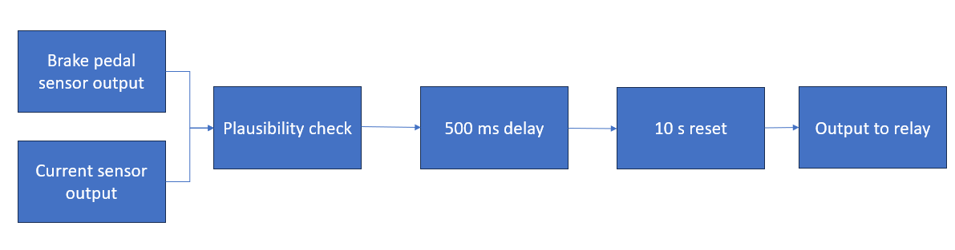
The shutdown circuit will be activated if the two conditions persist for over 500ms and BSPD will reset itself after 10 seconds.

A DC Current sensor LEM CAB-SF 500-C is used to measure the power delivered to the motor and for measuring pressure in the brake line, the Brake pressure sensor Honeywell MLH03KPSL01A is used.
The detailed research on the Sensors and electronics could be reviewed on the attachment here: Sensors and Electronics- Google Docs

Design:
To detect implausibility (Power > 5 KW and Pressure >30 bar), two comparators and one AND gate ICs are used. An LM393 comparator has been used for this purpose: if the voltage in the inverting terminal (- ve terminaI) is greater than the voltage in the non-inverting terminal (+ ve terminal), the output will be drawn to the voltage supply. If not, it is drawn from the ground. It is supplied by 5V in one terminal, which is the voltage that most of the BSPD operates with. If both the implausibility conditions are found to be true, both comparators used will give high output, and correspondingly output of AND gate would be high.The circuitry is shown below.
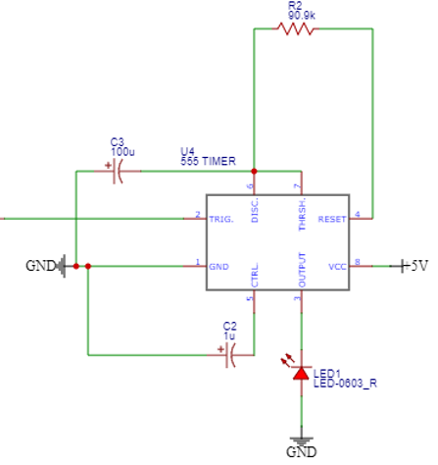
The delay circuit consists of a RC network in which, depending on the resistor's value, the time required to charge the capacitor to almost 99% of the input voltage. This time delay helps to verify if the conditions are present for more than the threshold and are non erroneous signals. So taking R = 10 kΩ and C = 10uF we can get 99% of charging and the required 500 ms of delay. After this, the output of the persistence check is fed to a 555 timer with a 10-second auto reset used in monostable mode as shown in figure. The time delay with a monostable mode is calculated as per below formulae:
Output pulse width(in sec) = 1.1 * R * C
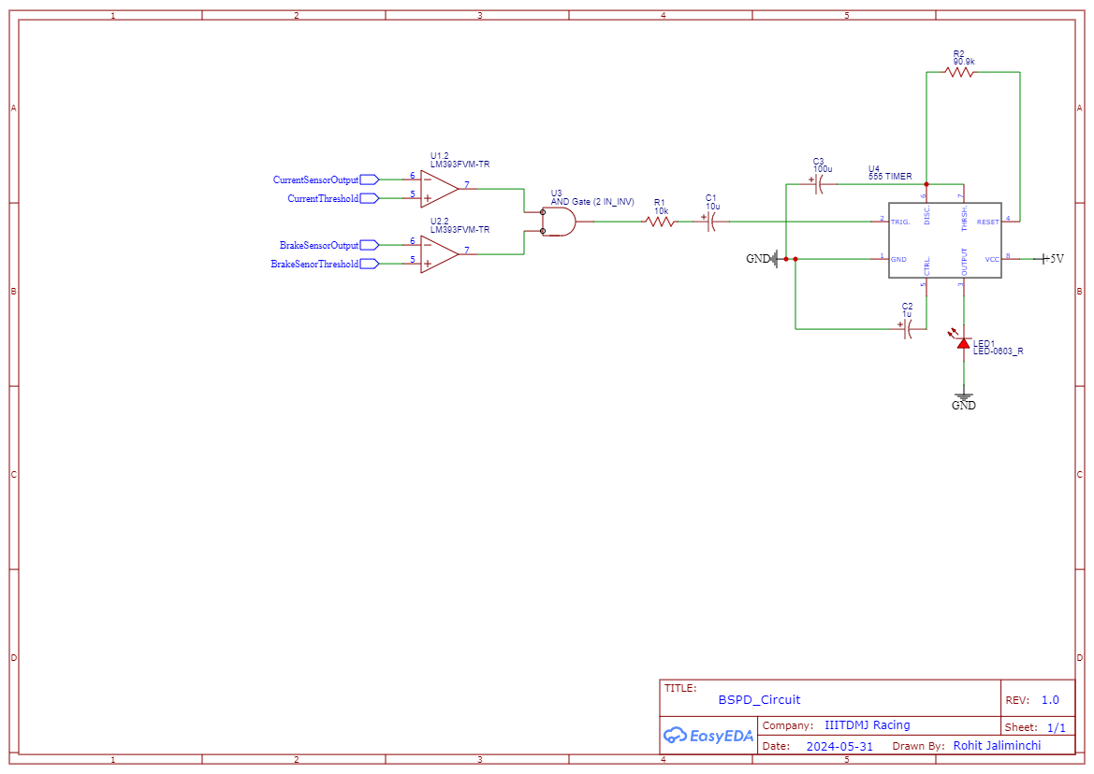
Taking C = 100uF and R =90.9 kΩ, we get time delay as
T = 1.1 * 0.0001 * 90900
T = 9.999 sec ≈ 10 sec

Motor/Controller Packaging in Vehicle

Key Considerations :
- Compactness:
- Motor : Ensure the ME1905 fits within the motor bay, minimizing space interference.
- Controller : Place the Sevcon Gen4 close to the motor to reduce wiring length and power losses.
- Power Density:
- Cooling : Integrate air/liquid cooling for optimal temperature management.
- Wiring : Use heat-resistant, high-quality wiring for reliable power delivery.
- Safety:
- Insulation : Proper electrical insulation to prevent shorts and shocks.
- Vibration Isolation : Use anti-vibration mounts to protect components.
- Fire Suppression : Consider a fire suppression system within the motor bay.
- Structural Integrity:
- Mounting : Secure motor and controller with strong, lightweight brackets.
- Chassis Integration : Integrate into the chassis for added structural strength.
- Crash Protection : Ensure placement minimizes damage risk in collisions.

Layout Example:
- Motor Placement:
- Positioned centrally in the rear for optimal weight distribution.
- Mounted with custom brackets.
- Controller Placement:
- Mounted close to the motor in a separate compartment for better cooling and access.
- Connected via short, high-quality cables.
- Cooling System:
- Dedicated air vents and liquid cooling channels for both motor and controller.
- Heat exchangers in the airflow path.
- Safety and Protection:
- Fire-resistant materials in the motor bay.
- Anti-vibration mounts for motor and controller.
- Reinforced chassis areas for impact protection.

Additional Considerations:
- Weight Distribution : Low center of gravity by placing components low in the chassis.
- Maintenance Access : Easy access for checks and repairs.
- Environmental Protection : Use IP-rated components for dust and water protection.

This streamlined approach ensures optimal performance, reliability, and safety for the Motenergy ME1905 motor and Sevcon Gen4 Size-6 controller in our vehicle.
Drivetrain & differential:

A 3:1 gear ratio balances torque and speed, ensures efficiency, minimizes wear, offers versatility, simplifies design, and optimizes performance, making it a preferred choice for chain drive systems. Static structural analysis is crucial for a chain drive system to ensure its strength, durability, and to prevent premature failure under operational loads.
Here are some snapshots of the static structural analysis of the gear which gives information about the pressure distribution as well as the deformation caused by the external loads, which would also be available in the above folder of reference to the transmission system. This helped us in getting a better understanding of load capacity of the following chain-drive system range of usage and its efficiency.
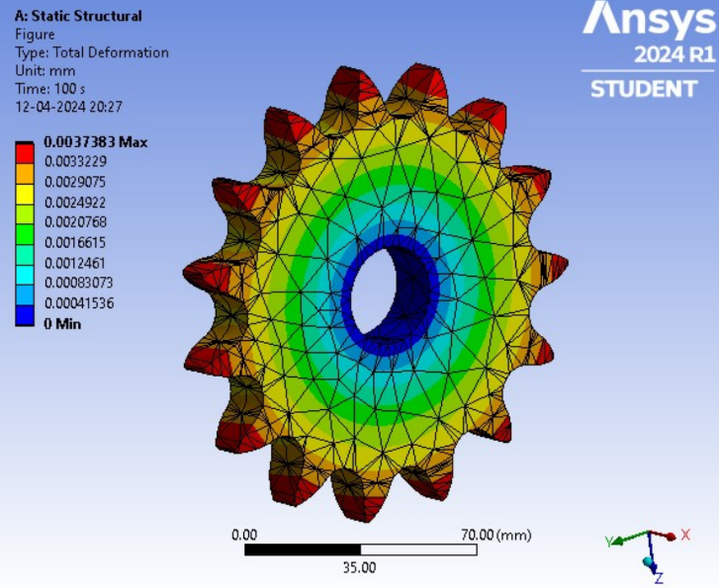
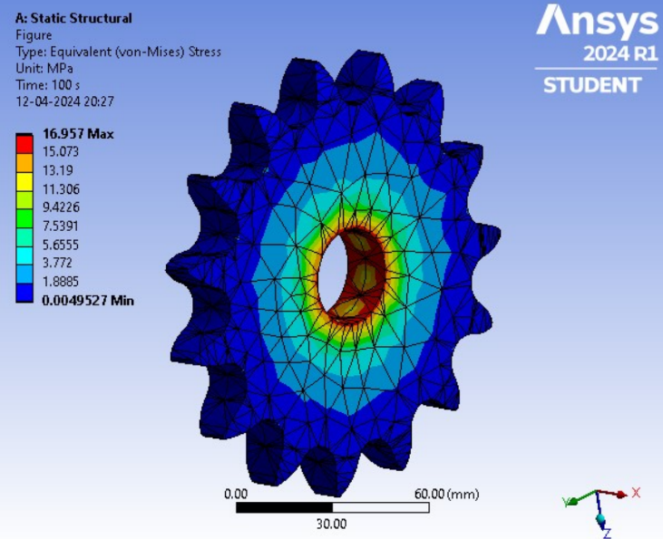

Specification | Value
Driver Gear Teeth | 15
Driven Gear Teeth | 45
Material | 4340 steel

Differential:
The open type differential, and is the most common type of differential.
Using an open gear differential in a Formula Student racing car provides several benefits:
- Cost-Effective: Cheaper to manufacture and maintain.
- Weight Savings: Lighter unit improves performance.
- Reduced Complexity: Easier to install, set up, and maintain.
- Predictable Handling: Consistent and predictable vehicle behavior.
- Minimized Power Loss: Efficient with minimal power loss in similar traction conditions.
- Simplicity in Design: Fewer moving parts reduce mechanical failure risk.
- Driver Training: Helps novice drivers understand vehicle dynamics.

Some Illustrations of the design models
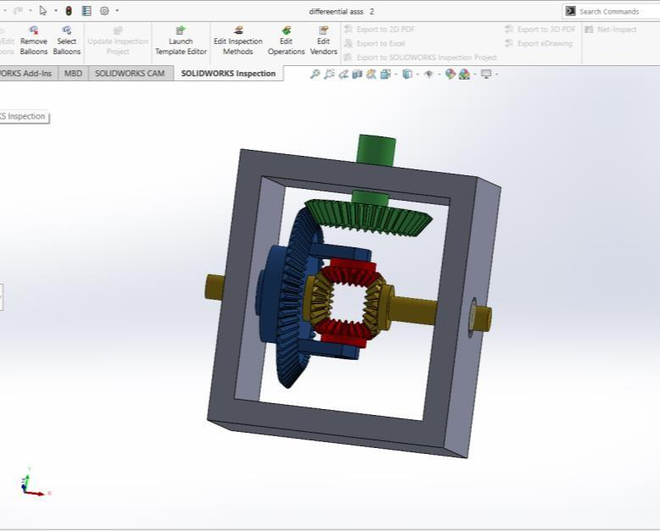
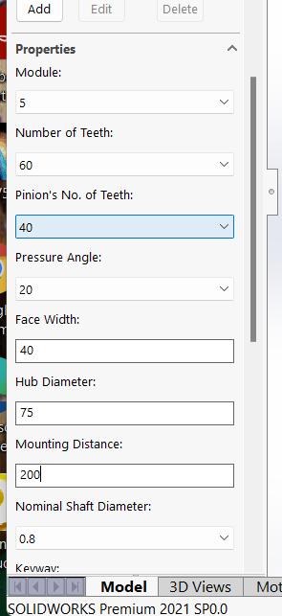
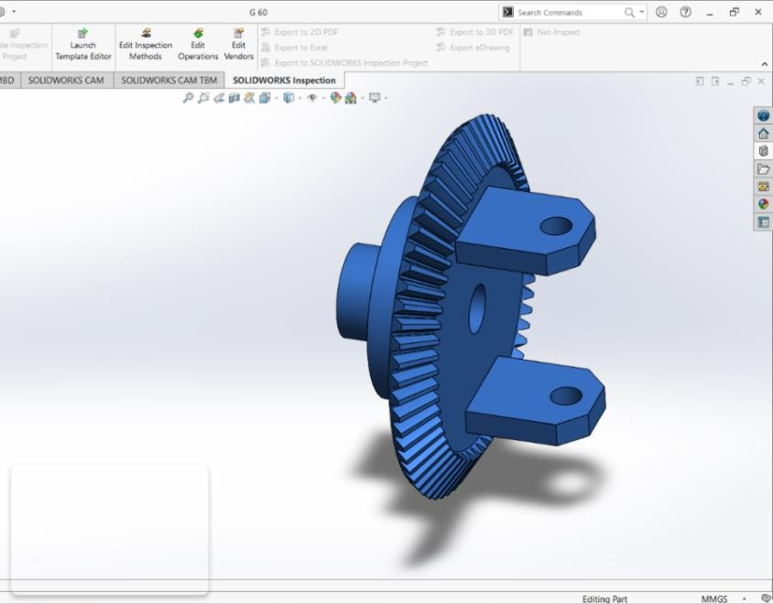

Part Drawing of Crown Wheel Assembly of Differential

Analysis illustrations
Moment at 1500 N-MM
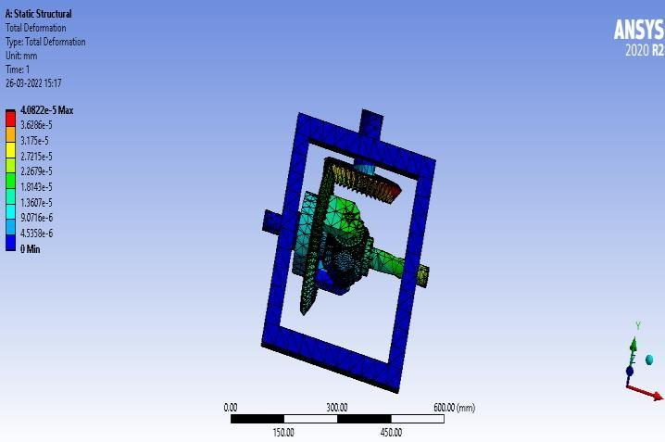
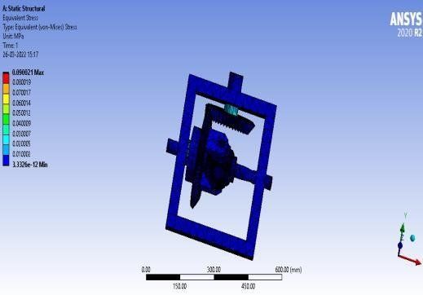

Total Deformation at 1500 N-mm Equivalent Von mises Stresses at 1500 N-mm

The obtained resultant von mises stresses and total deformation are tabulated in the following tables.
Moment (N-mm) | Material | Von Mises Stress (MPa) | Total Deformation (mm)
100 | Structural Steel | 5.81E-05 | 0.00588
500 | Structural Steel | 2.90E-05 | 0.029399
1000 | Structural Steel | 5.81E-06 | 0.058798
1500 | Structural Steel | 8.71E-05 | 0.088197

Graphical data

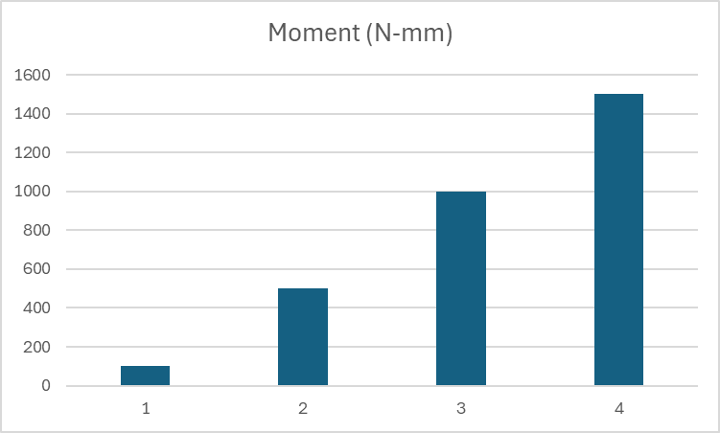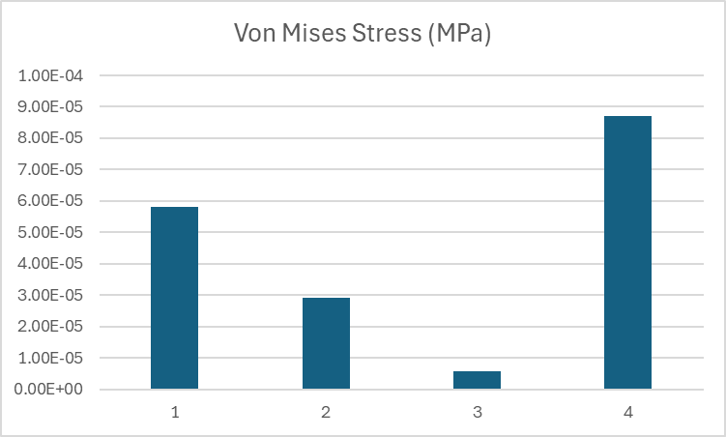
(a) (b)
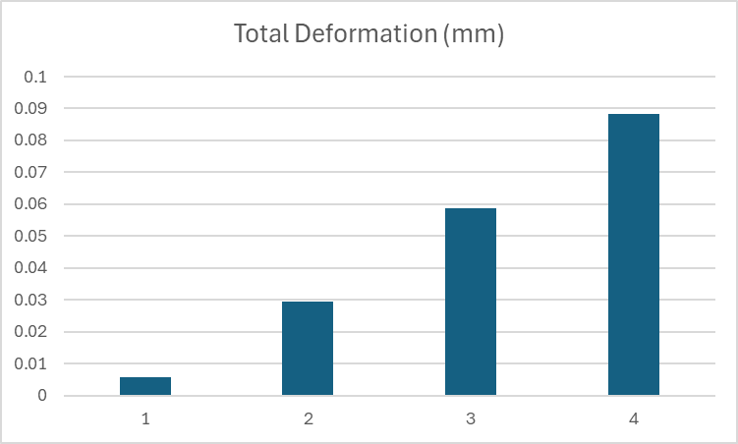

(c)
Fig :- Graphical analysis of (a)Moment [N-mm]
(b)Von-mises Stress[MPa]
(c)Total Deformation [mm]

For further calculations and analysis details, Differential Calculations And Details could be referred to.
Accumulator
Energy And Power Calculations:
Power:
Peak Power: Charging Voltage * Peak Current
153*340 = 52020W or 52.02kW
Continuous Power: Nominal Voltage * Continuous Current
131.4*100 = 13140W or 13.14kW

Energy = Effective capacity*Nominal Voltage per cell* Cells in series
Effective capacity for the cell :
@2C- 50Ah
@3C- 45Ah (The effective capacity reduces to 90% at 3C)
Energy at 1.7C: 26280 Wh (26.28 kWh)
Parameters | Value
Peak Power | 52.02kW
Continuous Power | 13.14kW
Energy at 1.7C | 26.28 kWh

Energy and power estimations contain all the calculations with assumed approximations.

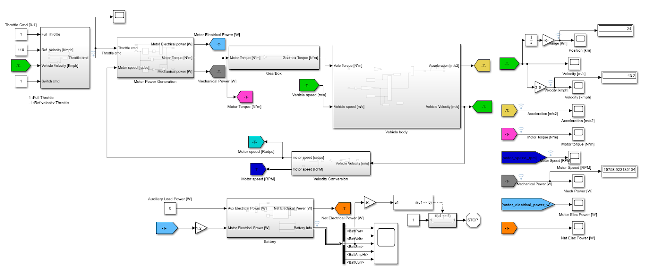
Powertrain Simulation in Matlab Simulink:

Matlab Model for EV PowerTrain
Specification | Details
Mass | 280Kg (Inc. driver)
Frontal Area | 1.0735m2
Time | 30 mins
Motor speed | 2500-6000 rpm
Torque | 30-70 Nm
Cell Configuration | 50Ah 3.65V NMC Prismatic cells
Arrangement | 4P 36S

Result Data:
Parameter | Value
Power | 15 kW
Vehicle Velocity | 43 km/h
Distance Traveled | 24 km

As per our calculations the simulation data justified our assumptions.
Hence, some graphical data for the battery performance analysis came out as:
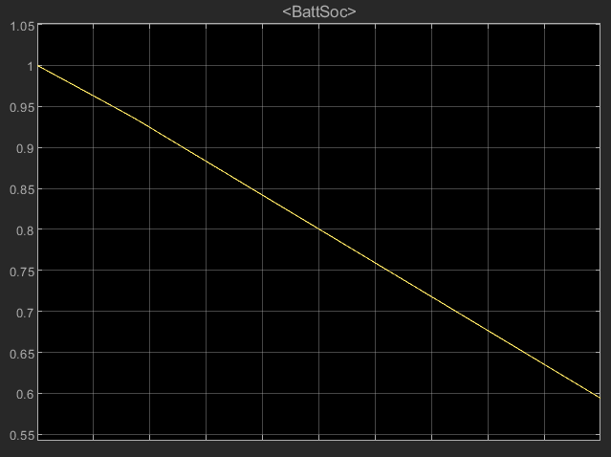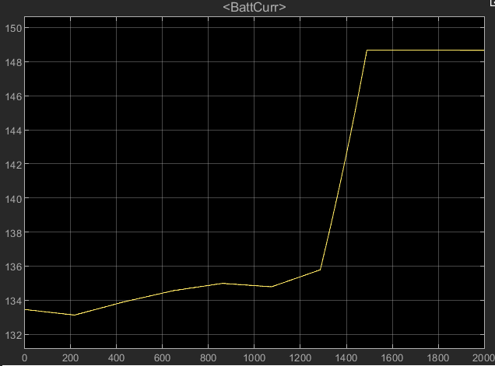
SOC of Battery Battery Current
For more details of our obtained results from the simulation can be referred to in the following document of Simulation Results, also to go through the simulation model.
Cell Modules
Cell Selection :
Selecting cells for an EV accumulator pack is crucial for optimizing performance, safety, and cost. Key factors include:-
- Energy Density : Affects driving range.
- Power Density : Impacts acceleration and regenerative braking.
- Lifecycle : Determines longevity.
- Safety : Prevents thermal runaway.
- Cost per kWh : Influences overall cost.
- Supply Chain Stability : Ensures availability.

The best cell which comes of our battery pack manufacturing comes out to be as 3.6V 50Ah NMC chemistry Prismatic cell, which is manufactured by Hawkeye Innovations, LLC, as the following tabularized data is what we approached for our cell requirements :
Specification | Value
Nominal Voltage | 3.6V
Capacity | 50Ah
Energy Density | 200-250 Wh/kg
Thermal Stability | Up to 60°C (operating)
Cycle Life | 2000-3000 cycles

Pack configuration :
To configure the 120V, 200Ah battery pack with 3.6V, 50Ah NMC cells, we connect 34 cells in series to achieve approximately 122.4V. To meet the 200Ah capacity, we replicate this series string four times in parallel, using 136 cells in total.

Parameter | Value
Cell Voltage | 3.6V
Cell Capacity | 50Ah
Series Cells | 36 cells
Parallel Strings | 4 strings
Pack Voltage | ~129.6V
Pack Capacity | 200Ah
Total Cells Used | 144 cells

Cell segments :
This outlines the configuration of cell segments for a 200Ah, 120V battery pack using 3.6V, 50Ah NMC cells.
Parameter | Value
Voltage | 120V
Capacity | 200Ah
Cells | 144 x 3.6V, 50Ah NMC cells
Series Cells per Segment | 36 cells
Parallel Segments | 4 segments
Total Cells Used | 144 cells
Module Design | Four modules, each containing 36 cells in series
Thermal Management | Cooling systems and temperature sensors in each module
BMS | Continuous monitoring and balancing of voltage and temperature
Safety Features | Protective circuits, thermal insulation, and robust casings
Mechanical Design | Modular design for easy maintenance and structural integrity
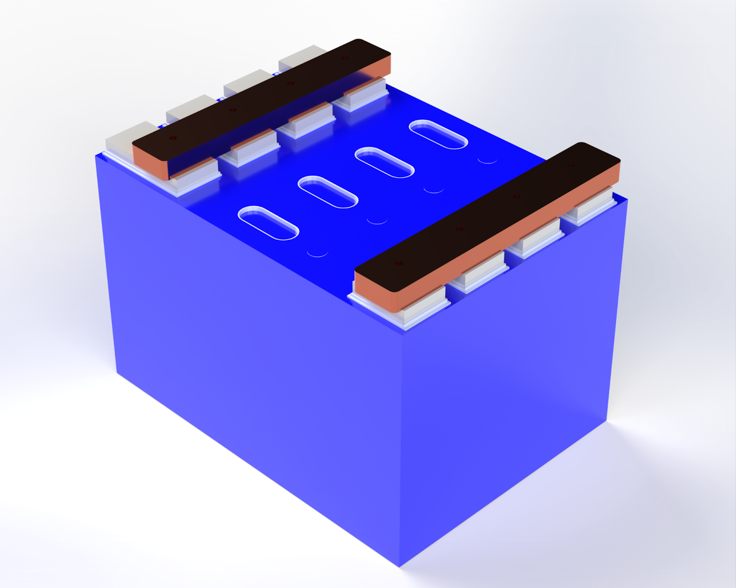

A part of cell segment is shown in
the adjacent figure

Cell Module Packaging and Interconnect Design :
- Connect 36 cells in series, each composed of 4 parallel cells, to achieve a total voltage of 129.6V with a capacity of 200Ah.
- Use robust, heat-resistant materials and cooling systems for thermal management.
- Employ high-quality conductive materials like copper for busbars and ensure secure electrical connections.
- Integrate a BMS for monitoring cell parameters and active balancing.
- Implement protection mechanisms like fuses and mechanical supports to safeguard against faults and physical damage.
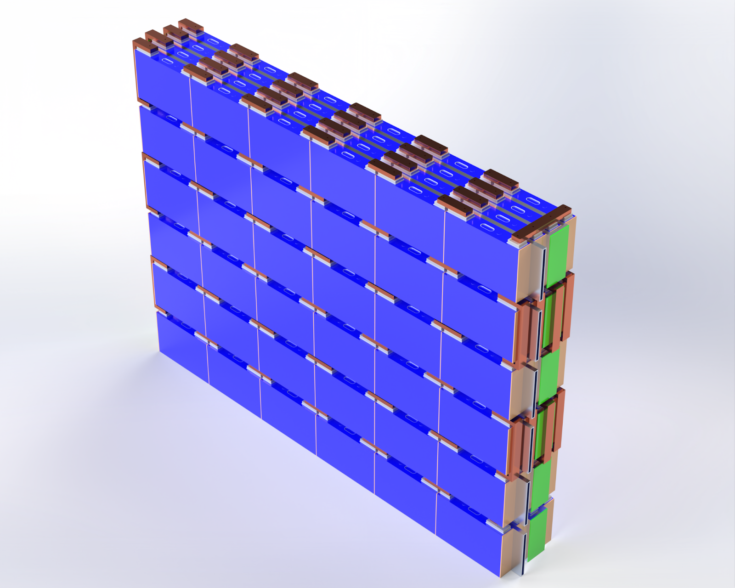


Heat Calculation:
Parameter | Value
Internal resistance of cell (R) | 0.8 mohm
Current at 3C | 150 A
No. of cells | 144
Cross-sectional area of a single cell (AcellA_{cell}Acell​) | 0.04216546m2
Temperature difference (ΔT) | 25∘C
Using calculations as done in the Cell modules and Calculations- Google Docs
h = 18.30. Hence, the battery pack must be equipped with the liquid cooling method to smoothly operate and maintain its life cycles and health.

Busbar Calculations:
Parameter | Value
Maximum current | 600A
Internal resistance | 0.0008 ohms
Maximum temperature | 50°C
Operating temperature | 25°C
Thermal conductivity of copper | 401 W/m·K (at 25°C)
Distance from cell to cooling system | 0.05 meters (50 mm or 5 cm)
Rth | 0.001054m2⋅K/W
A =1.796×10−3m2
So, the required cross-sectional area of the busbar is approximately 1.796×10−3m2.
Hence, 7.6 mm thickness, 18 mm width busbar used.
Material - copper

BMS, AIRs, IMD
Battery Management System
The Orion BMS (Battery Management System) is an advanced and comprehensive solution designed to protect and optimize the performance of lithium-ion battery packs. Here are several key reasons why using the Orion BMS is beneficial:
Parameter | Specification
Cell Capacity | Up to 180 cells in series
Cell Voltage Range | 0 to 5V per cell
Total Pack Voltage Range | Up to 900V
Current Measurement Range | -1000A to +1000A (depending on sensor used)
Temperature Measurement Range | -40°C to 125°C
Balancing Current | Up to 200mA per cell (passive balancing)
Communication Protocols | CANBUS 2.0B, optional analog outputs
Digital Inputs/Outputs | Configurable digital I/O for control and monitoring
Isolation Monitoring | Built-in isolation monitoring
Power Consumption | Typical < 2W
Operating Temperature Range | -40°C to 85°C
Safety Features | Over & under-voltage, over-current, over-temperature protections, fault detection, and isolation monitoring

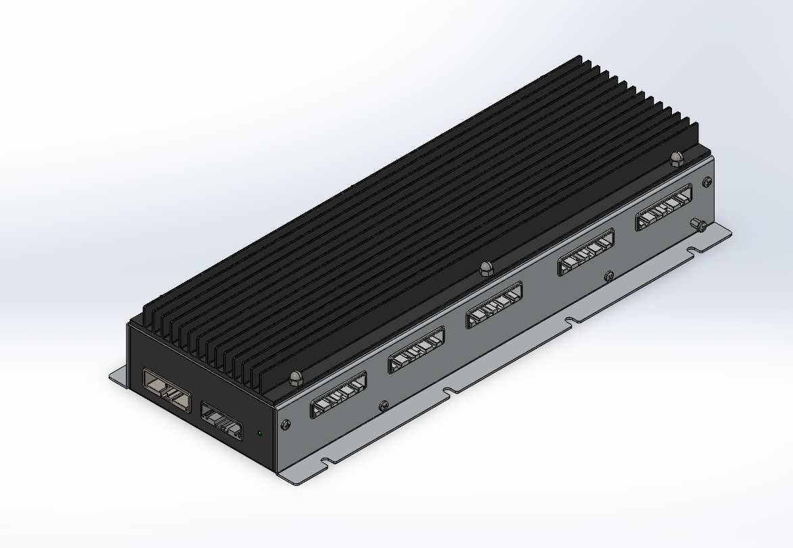
Orion 2 BMS

System Connections:

OrionBMS: Central to the system, managing inputs/outputs, pack voltage, and cell bank monitoring.

Components Connected:
  - Laptop Computer: Communicates with OrionBMS via OBD2 Diagnostic Port
  - User Display: Shows SOC gauge, live data, etc., connected via CANBUS.
  - Charger: Enables charge through CANBUS.
  - DC Load: Includes motor and inverter, connected via CANBUS.
  - Thermistors and Fan: Monitored and controlled by OrionBMS.
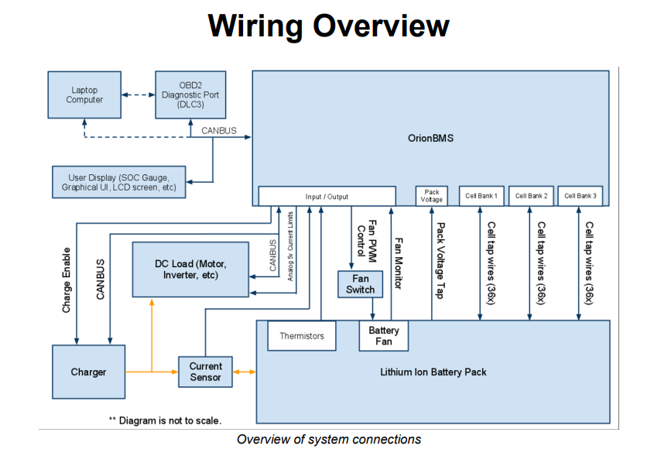
  - Current Sensor: Monitors current flow to/from the battery.

Connector Locations on Orion BMS:
- Cell Tap Connectors: For cell groups (1-3, 4-6, 7-9, 10-12, 13-15).
- Pack Voltage Tap: Monitors overall battery pack voltage.
- Main Connector: Central connection point for system integration.
- Thermistor/Current Sensor: Inputs for temperature and current monitoring.
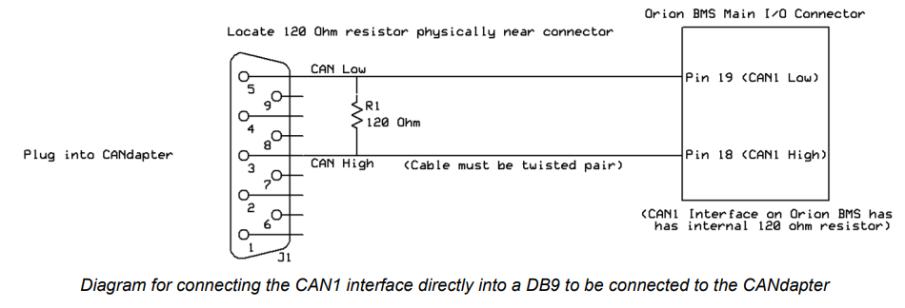
- Ground Lug: Must be grounded for safety.
CAN Interfaces:
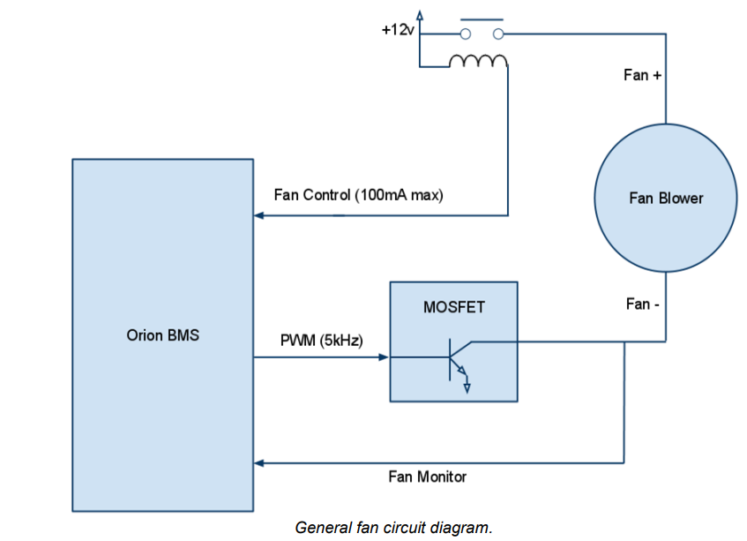
The Orion BMS provides two independent CAN interfaces, CAN1 and CAN2, supporting baud rates of 125, 250, 500, or 1000 Kbps. They require twisted pair wiring with shielded cables for optimal communication, and proper grounding to prevent damage to CAN transceivers. Termination with 120-ohm resistors at each end of the bus is essential for reliability. This setup ensures efficient and reliable communication, vital for the Orion BMS in various applications, particularly in noisy environments like vehicles.
Fan Controller:
The Orion BMS offers robust thermal management:
- Supports up to 4 thermistors directly, expandable
to over 800
- Fan control options include on/off and variable
speed via PWM.
- Fan monitoring for voltage detection.
- Crucial for optimizing battery performance and
longevity.
Current Sensor and Thermistor Setup
The Orion BMS provides accurate current sensing and temperature monitoring capabilities crucial for efficient battery management. With flexible current sensor wiring and thermistor configuration options, it ensures precision and safety in battery operation. Installation considerations, including proper isolation and protection against shorts, further enhance reliability.
Thermistor Configuration:
- The Orion BMS main unit supports up to four directly connected thermistors for temperature monitoring.
- Thermistors should be strategically placed throughout the battery pack for representative temperature readings.
- One of the four thermistors can be designated as an intake air temperature sensor for cooling management.
- An external thermistor expansion module is available for monitoring additional temperatures, up to 804 thermistors total.
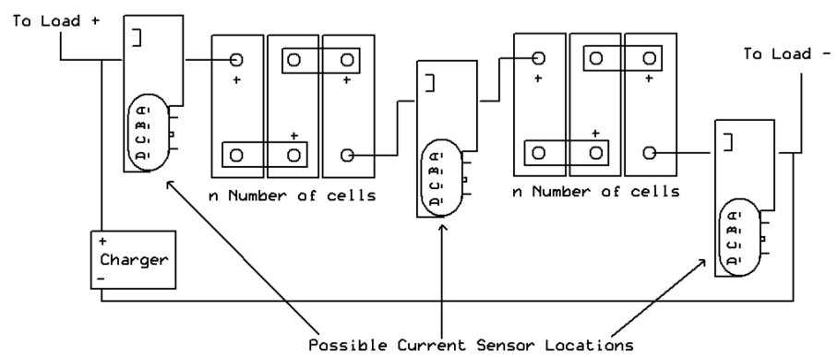
- Thermistors are 10K NTC thermistors, with options for different B values for custom applications.
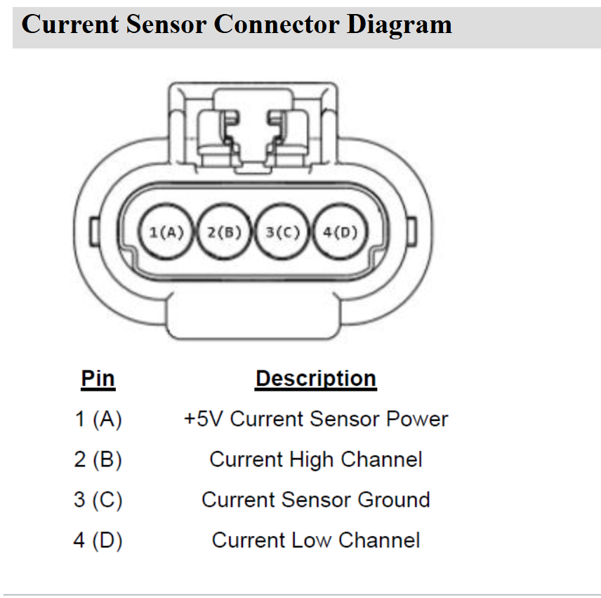

Hall effect sensor Schematic

Safety Disconnects and Fuse:
- Mid-pack disconnects advised for safety in high voltage or high amperage packs.
- Proper isolation is crucial; Orion BMS provides 2.5kV safety isolation.
- Disconnects/fuses must be between connectors for safety; incorrect wiring can damage the BMS.
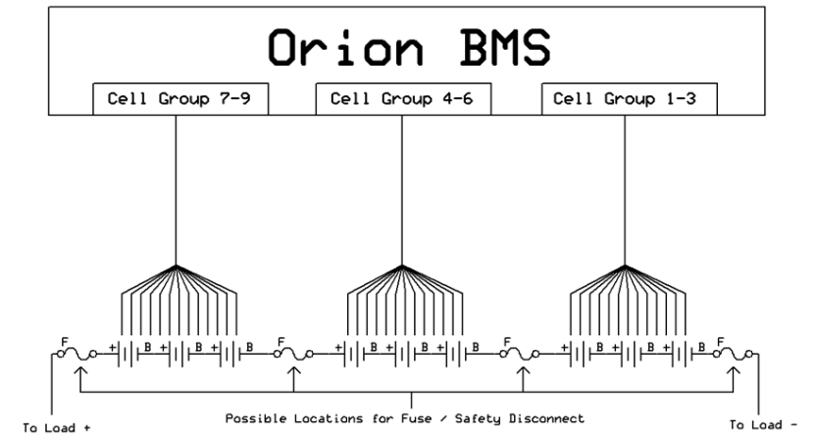
- Diagram helps locate disconnects/fuses; flexibility in placement within Orion BMS wiring.

Fuse location Schematic

Voltage Tap Harness Lengths
Standard Lengths:- Available in 6-foot and 12-foot options.
Accuracy Impact:- Length affects voltage readings; default calibration for 6-foot lengths.
Recommended Lengths:
- Revision B, C & D: Maximum recommended length of 12 feet for optimal accuracy.
- Revision E: Improved to support cable lengths up to 30 feet.
Additional Error for Longer Cables:
Revision E allows longer cables with specified additional error:
- 18-foot: +/-1.5mV
- 24-foot: +/-2.3mV (not recommended)
- 30-foot: +/-3.2mV (not recommended)
- 36-foot: +/-4.0mV (not recommended)
Proper selection of voltage tap harness lengths ensures accurate voltage readings with the Orion BMS, with longer cables supported by specific revisions and calibrated accordingly.

Firmware
Firmware refers to the embedded software that controls the operation of the Orion BMS hardware components. This document provides a comprehensive overview of the firmware functionalities, including initialization, cell balancing, fault handling, communication protocols, redundancy, sensor integration, and data filtering.
Firmware Update Process :
The process of updating Orion BMS firmware involves several steps to ensure a smooth and successful transition. Here's a general outline of the update process:
1. Preparation: Before initiating the firmware update, it is crucial to review release notes, backup configuration settings, and ensure a stable power supply to the BMS unit.
2. Download Firmware: Obtain the latest firmware version from the official Orion BMS website or authorized distributors.
3. Connect to Utility O2: Use the Utility O2 software to establish a connection with the Orion BMS device that requires firmware updating.
4. Firmware Installation: Follow the on-screen instructions provided by Utility O2 to upload the new firmware to the BMS unit.
5. Verification: After the firmware update is complete, verify the installation and ensure that the BMS device functions correctly.

Detailed explanations of each component, along with insights from the Orion BMS2 Utility Manual, ensure optimal performance and safety are moreover filled in the document of Battery Management System.
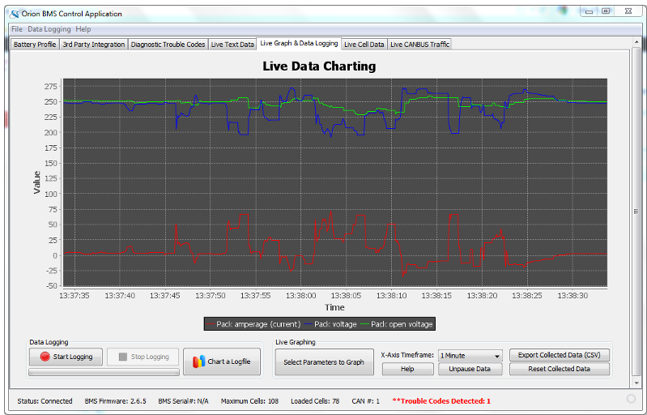
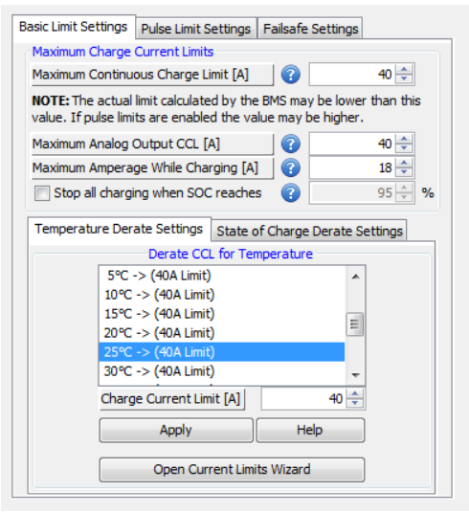

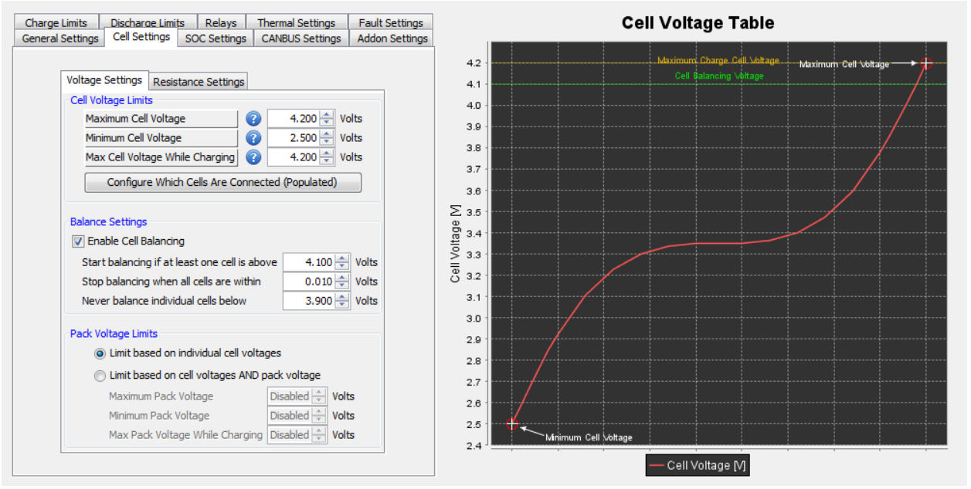
Basic Limit Settings Live Data Handling

Cell Settings
Fault Detection Mechanisms :
- Voltage Monitoring :
- Monitors each cell's voltage to ensure it stays within safe limits.
- Detects overvoltage and under-voltage conditions.
- Temperature Monitoring :
-Tracks cell and module temperatures.
- Identifies over-temperature and under-temperature conditions.
- Current Monitoring :
- Measures charging and discharging currents.
- Detects overcurrent situations such as short circuits or excessive current draw.
- Isolation Fault Detection :
- Ensures electrical isolation between the high-voltage system and the vehicle chassis.
- Detects insulation failures.
Fault Response Actions :
- Alerts and Notifications :
- Sends notifications through the CAN bus to the vehicle's control system.
- Triggers visual and auditory alarms.
- Throttling :
- Limits current flow to protect the battery pack.
- Prevents further damage until the fault is resolved.
- Shutdown Procedures :
- Initiates a complete system shutdown in severe fault conditions.
- Isolates the battery pack to prevent further risk.
- Data Logging :
- Logs all fault events for diagnostic purposes.
- Records time-stamped data of fault types and conditions.
- Configuration and Customization :
- Users can customize fault thresholds and responses using the Orion BMS Utility software.
- Specific voltage, temperature, and current limits can be set based on application needs.
- Firmware updates improve fault handling and add new features.
These fault handling mechanisms in the Orion BMS 2 firmware ensure the safety and longevity of the battery pack, providing robust protection against a wide range of potential issues.

Accumulator Isolation Relay [AIRs]:
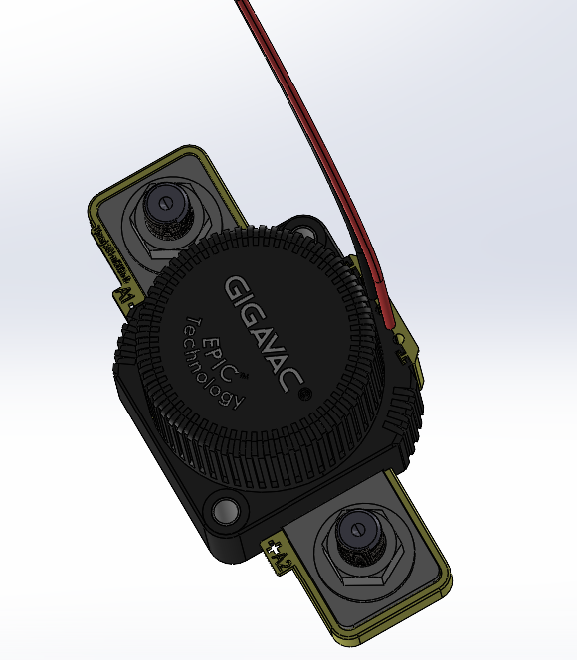
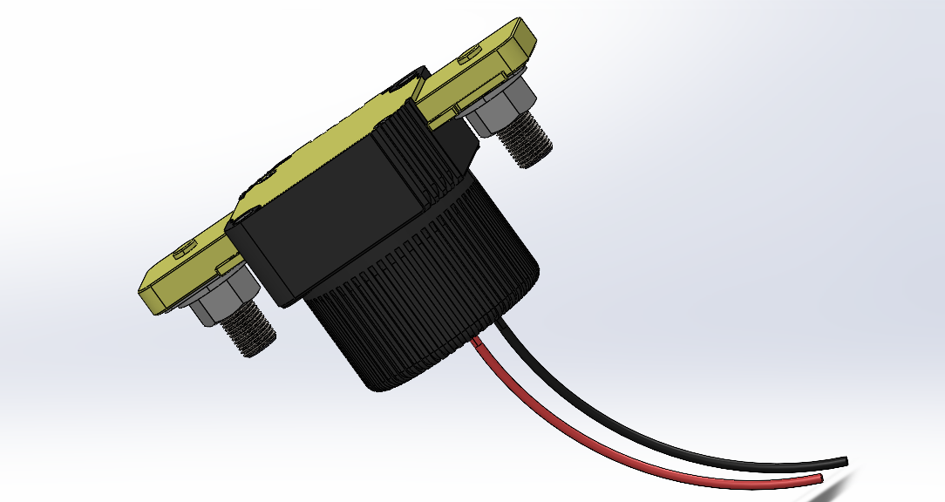
According to EV5.6 of the Formula Bharat rules, each accumulator must have at least two accumulator isolation relays. An AIR is a normally open contactor that is regulated by the vehicle's shutdown circuit. The AIRs are meant to isolate both poles of the tractive battery, ensuring that no high voltage is present on the accumulator's output. An AIR is chosen based on its rated voltage, continuous current capacity, and interrupt rating. An AIR's interrupt rating indicates the maximum power in the circuit that can be broken.

After analysis the AIR selected for this system is Gigavac GX14CB. It is easier to use. Its specifications are given below.
Description | Attribute
Coil Voltage | 24 VDC
Contact current rating | 350 A
Switching voltage | 800 VDC
Coil Current | 97 mA
Operating temperatures | Max - +85 C Min - -55 C

Insulation Monitoring Device[IMD]
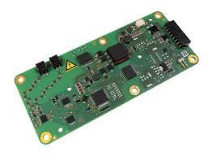
Insulation Monitoring Devices play a critical role in ensuring the safety and reliability of electrical systems by continuously monitoring insulation resistance and detecting faults that could lead to electrical failures or hazards.
Reasons for the IT system with insulation monitoring
1.Optimised maintenance
2.Increased operating reliability
3.Improved economic efficiency
4.Increased accident prevention
5.Increased accident prevention
ISOMETER® iso175

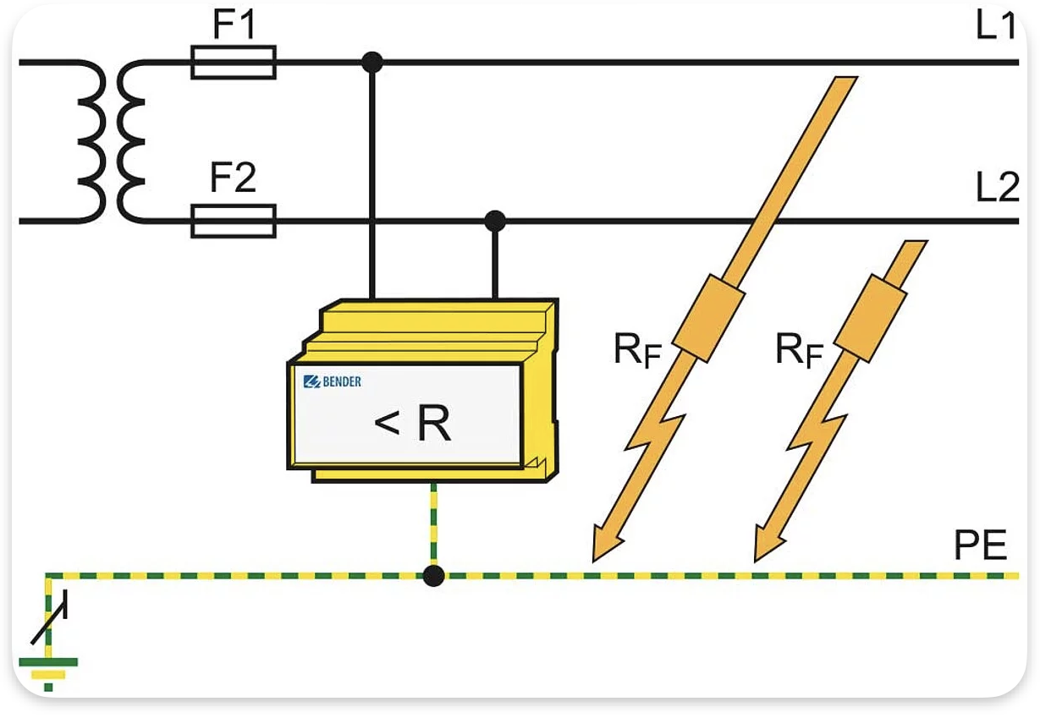
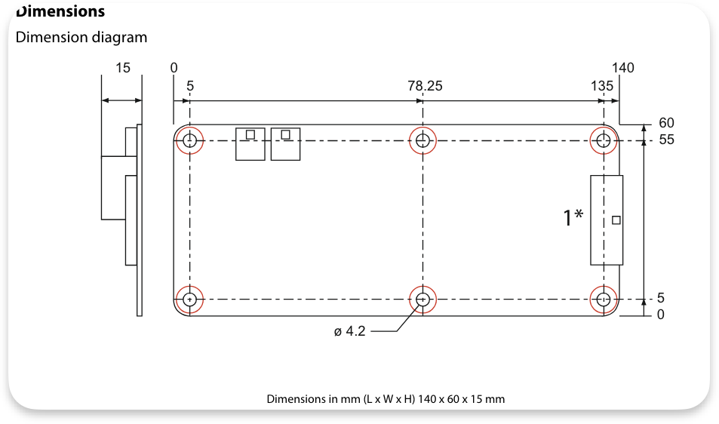
Operating principle of an insulation monitoring device : These devices connect between live supply conductors and earth, applying a measuring voltage (Um) and detecting faults by measuring the resulting current (Im). If an insulation fault occurs, closing the measuring circuit, the device evaluates the voltage drop across the measuring resistance (Rm). If this drop exceeds a set threshold, indicating insufficient insulation resistance, the device signals an alert. This early-warning system enables timely maintenance action

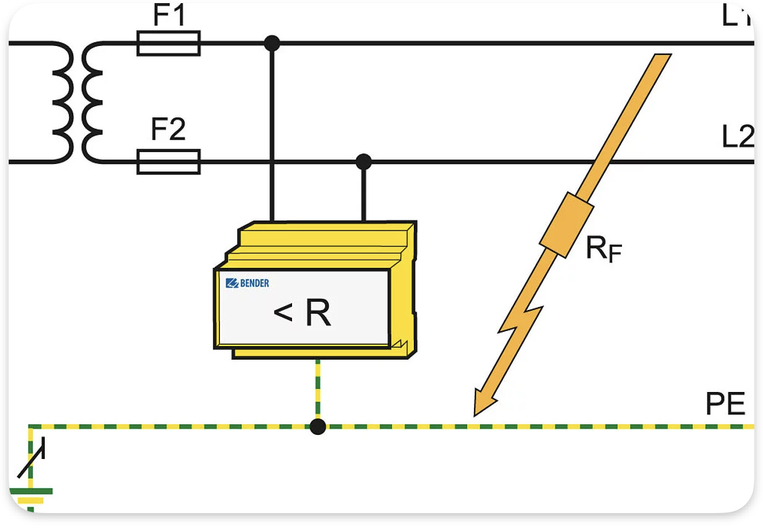
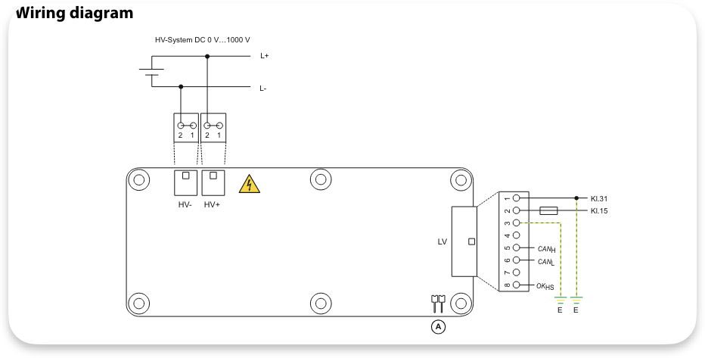

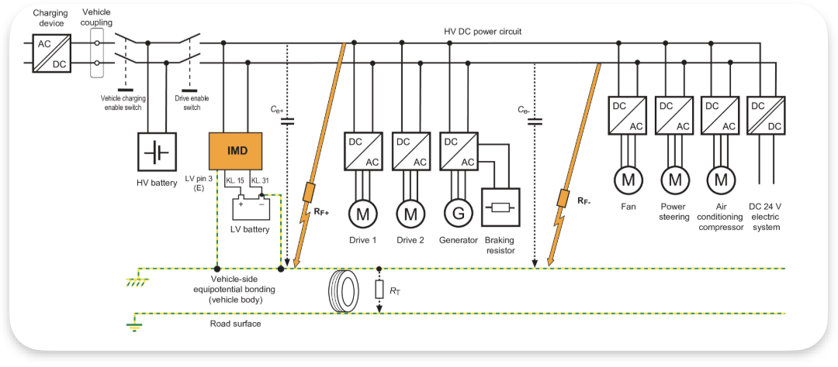

Features :
- Suitable for 12 V and 24 V DC systems (supply voltage)
- Insulation monitoring of DC insulation faults for unearthed systems (IT systems) DC 0…1000
- Continuous insulation resistance measurement RF_corrected = 0…35 MΩ (RF_ original = 0…50 MΩ)
- Response time ≤ 30 s for insulation resistances ≤ 500 Ω/Volt and system leakage capacitances ≤ 2μF
- Insulation measurement also when the vehicle's HV electric system is not energized
- HV connection monitoring (offline self test)
- Continuous monitoring of the earth connection
- Insulation measurement for system leakage capacitances up to 10 μF can be configured by setting parameters in the high capacitance (“High Capacity“) profile.
- Undervoltage detection
- 1 Load-dump protection up to 58 V
Interfaces:
- Digital output for device error message (OKHS)
- As an alternative
- HS-CAN interface with the following protocols
- Bender CAN
- CAN-SAE J1939
- All outputs short-circuit proof
It has an active, patented measuring method for continuous monitoring of the insulation resistance in a high-voltage system Because high voltage connections in insulation monitoring devices offer enhanced sensitivity, accuracy, coverage, standardization, and safety.
Special Feature: Integrated Self Diagnosis
Integrated self-diagnosis enhances the performance, reliability, safety, and cost-effectiveness of insulation monitoring devices by enabling continuous monitoring of their health and functionality. Integrated self-diagnosis in these devices detects issues, classifies errors, generates alerts, initiates automatic error resolution, provides troubleshooting guidance, and facilitates timely maintenance interventions. This ensures the reliable operation of the monitoring system.

Battery/BMS Thermal Management

Thermal Management Requirements:
Parameter | Value
Peak Heat Generation | 259.2 kW (during peak load)
Desired Temperature Range | 25°C - 50°C
Cooling Medium | Liquid (water/glycol mix)
Heat Transfer Coefficient | 500 W/m²·K

Cooling Liquid Flow Rate:
Parameter | Value
Heat Transfer Rate (Q) | 259,200 W or 259.2 kW
Specific Heat Capacity of Coolant (c_p) | 4.18 kJ/kg·°C
Temperature Difference (ΔT\Delta TΔT) | 25°C
Mass Flow Rate (m˙\dot{m}m˙) | 2.479 kg/s

Flow Rate:
Parameter | Value
Mass Flow Rate (m˙\dot{m}m˙) | 2.479 kg/s
Density of Coolant (ρ\rhoρ) | 1000 kg/m³
Volumetric Flow Rate | 2.479 L/s

Results:
Calculation | Value
Heat Energy to be Dissipated | 259,200 W or 259.2 kW
Required Coolant Flow Rate | 2.479 L/s
Temperature Rise Managed | 25°C to 50°C
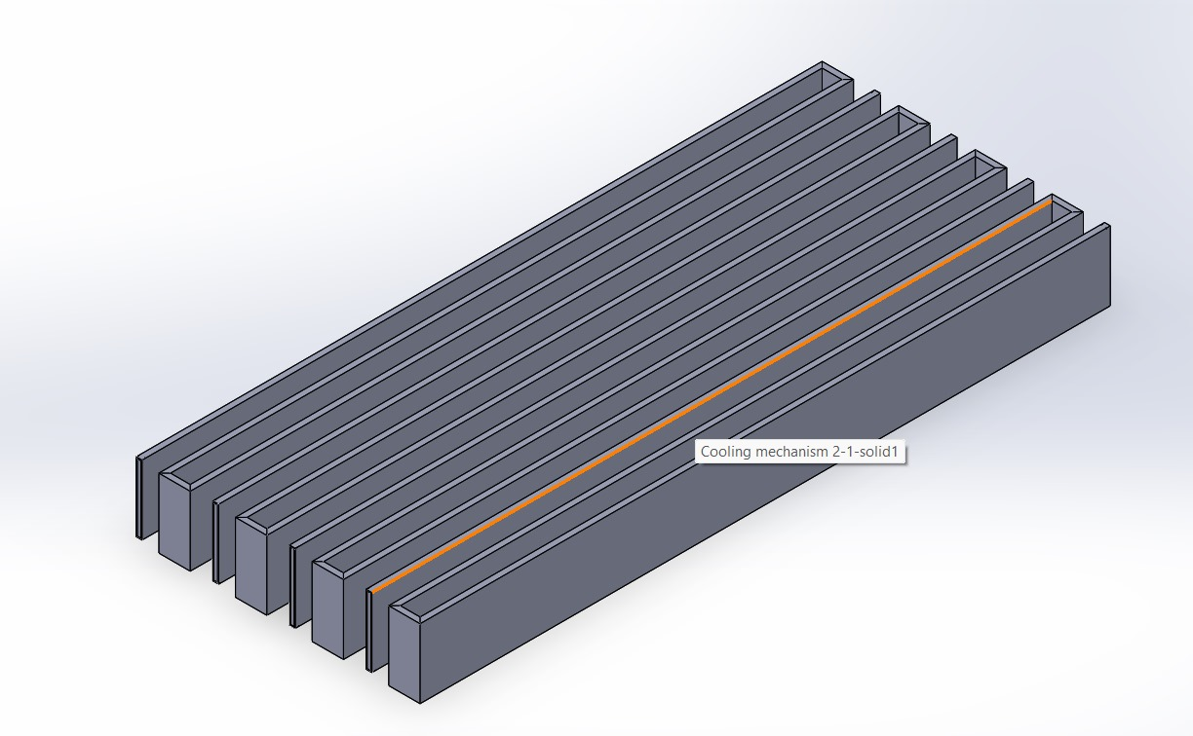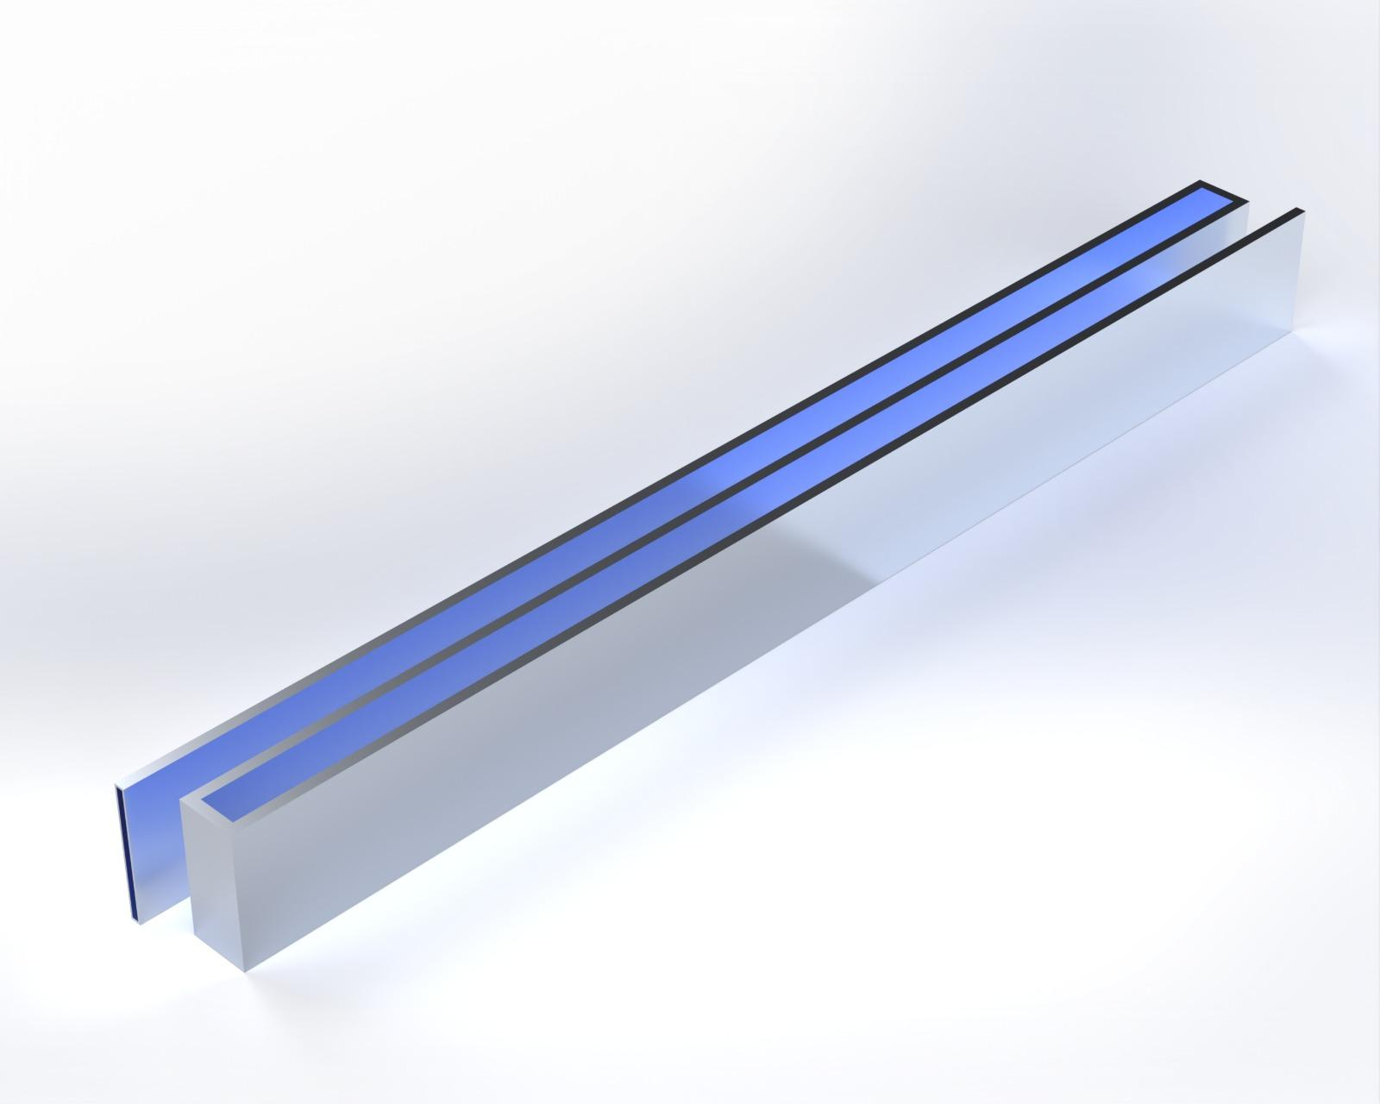
CAD Model For Fluid Flow in Battery
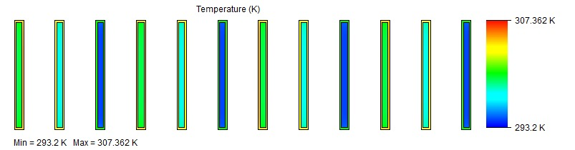
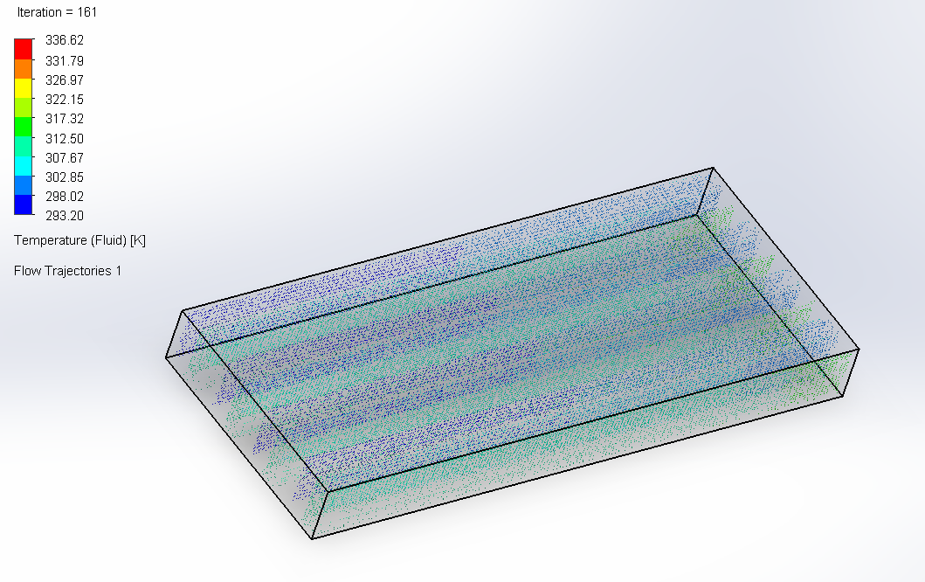

Side View Temperature Gradient

The Detailed calculations could be found in
the attachment shared below:
Accumulator Thermal and Casing. Battery Thermal Fluid Flow
Battery Auxiliaries
Fuses-
Protects the battery pack from overcurrent conditions.
The fuse that was best suitable for our accumulator pack configuration is Bussmann Eaton HV Fuse.
Justification for Selection :
- Current Rating : The 250A rating is suitable for the 200Ah pack, providing a sufficient safety margin to handle potential overcurrent without nuisance tripping.
- Voltage Rating : The 150V DC rating comfortably exceeds the 130V maximum voltage of the pack, ensuring reliable operation within the pack's voltage range.
- Reliability : Bussmann Eaton is known for high-quality and reliable components, which is crucial for the safety-critical application of battery protection.
- Safety Compliance : The fuse meets automotive and industrial safety standards, ensuring compliance with industry regulations.
Installation :
Place fuses close to the positive terminal of each series string or at strategic
points where current protection is critical. Ensure secure, low-resistance
connections.
Maintenance Plugs-
Enables safe disconnection of the battery pack for maintenance or emergencies.
The maintenance plug by TE Connectivity HVP 800 was found to be most compatible with our accumulator pack.
Justification for Selection :
- Current and Voltage Rating : allowing for safe handling of the current and voltage, rating of 250A, up to 450V
- Durability : Designed for high durability and repeated use, which is essential for maintenance operations.
- Safety Features : Includes features to prevent accidental disconnections and ensure safe handling.
Installation :
Position plugs in accessible locations for easy disconnection. Ensure proper
insulation and secure connections to avoid accidental short circuits.
HV/LV Connectors -
High voltage (HV) connectors enable safe and efficient transmission of high voltage electricity over long distances, while low voltage (LV) connectors facilitate a wide range of lower voltage applications with safety and ease of use.
- Rating: 200A, 150V DC
Justification for Selection :
- Voltage and Current Rating: Suitable for the high voltage and current requirements of the battery pack.
- Insulation: High-quality insulation to prevent electrical arcing.
- Shielding: Shielded connectors to minimize electromagnetic interference.
Installation :
Ensure HV connectors are securely attached with proper shielding to minimize EMI. LV connectors should be accessible for monitoring and maintenance.
Cabling
High Voltage Cabling:
- Alpha Wire Xtra-Guard 4 of Gauge: 2/0 AWG & Rating: 600V
Justification for Selection :
- Gauge and Rating: Adequate for handling the high current without significant voltage drop or overheating.
- Insulation: High-quality insulation ensures safety and durability in harsh environments.
- Shielding: Shielded to prevent EMI, which is critical for reliable operation in noisy environments.
Installation:
Route HV cables to avoid sharp bends and abrasion points, securing them with clamps and ties. Ensure LV cables are neatly organized and properly insulated.

Accumulator Casing
The comprehensive approach results in a high-quality battery pack that meets the needs of our vehicle :-
Material Selected : Aluminum Alloy 6061
Criteria | Requirement | Al 6061 Performance
Mechanical Strength | High tensile and yield strength | Tensile Strength: 310 MPa
 |  | Yield Strength: 276 MPa
Weight | Lightweight | Density: 2.70 g/cm³
Thermal Conductivity | Good heat dissipation | Thermal Conductivity: 167 W/m·K
Corrosion Resistance | High resistance to corrosion | Excellent corrosion resistance
Manufacturability | Easy to machine and form | Good machinability and weldability
Cost | Cost-effective | Moderate cost

Electrical Isolation Safety -
Property | Mica Sheets | FS1000 Insulation Tape | Justification
Dielectric Strength | 1180 kV/cm | 600 kV/cm | Prevents electrical shorts and ensures reliable insulation.
Thermal Stability | Up to 1000°C | Up to 150°C | Maintains performance under high temperatures.
Mechanical Strength | Tensile Strength: 210 MPa | High tensile strength and durability | Provides mechanical protection from impacts and vibrations.
Flame Retardancy | Excellent (inherent property) | UL 94 V-0 rating | Enhances safety by preventing fire propagation.
Flexibility | Rigid | Flexible | Facilitates easy application and coverage.
Density | 2.7 g/cm³ | 1.5 g/cm³ | Lightweight, adding minimal weight to the overall structure.

Implementation in Accumulator Casing

Use Mica Sheets as Insulation Plates:

Placement: Between individual cells and around the inner casing walls.
  - Function: Provides primary electrical isolation and mechanical protection.
- Apply FS1000 Insulation Tape:
  - Placement: Around joints, connectors, and critical points where electrical isolation is crucial.
  - Function: Enhances overall electrical insulation, adds an extra layer of flame retardance.
The Detailed calculations could be found in the attachment here:
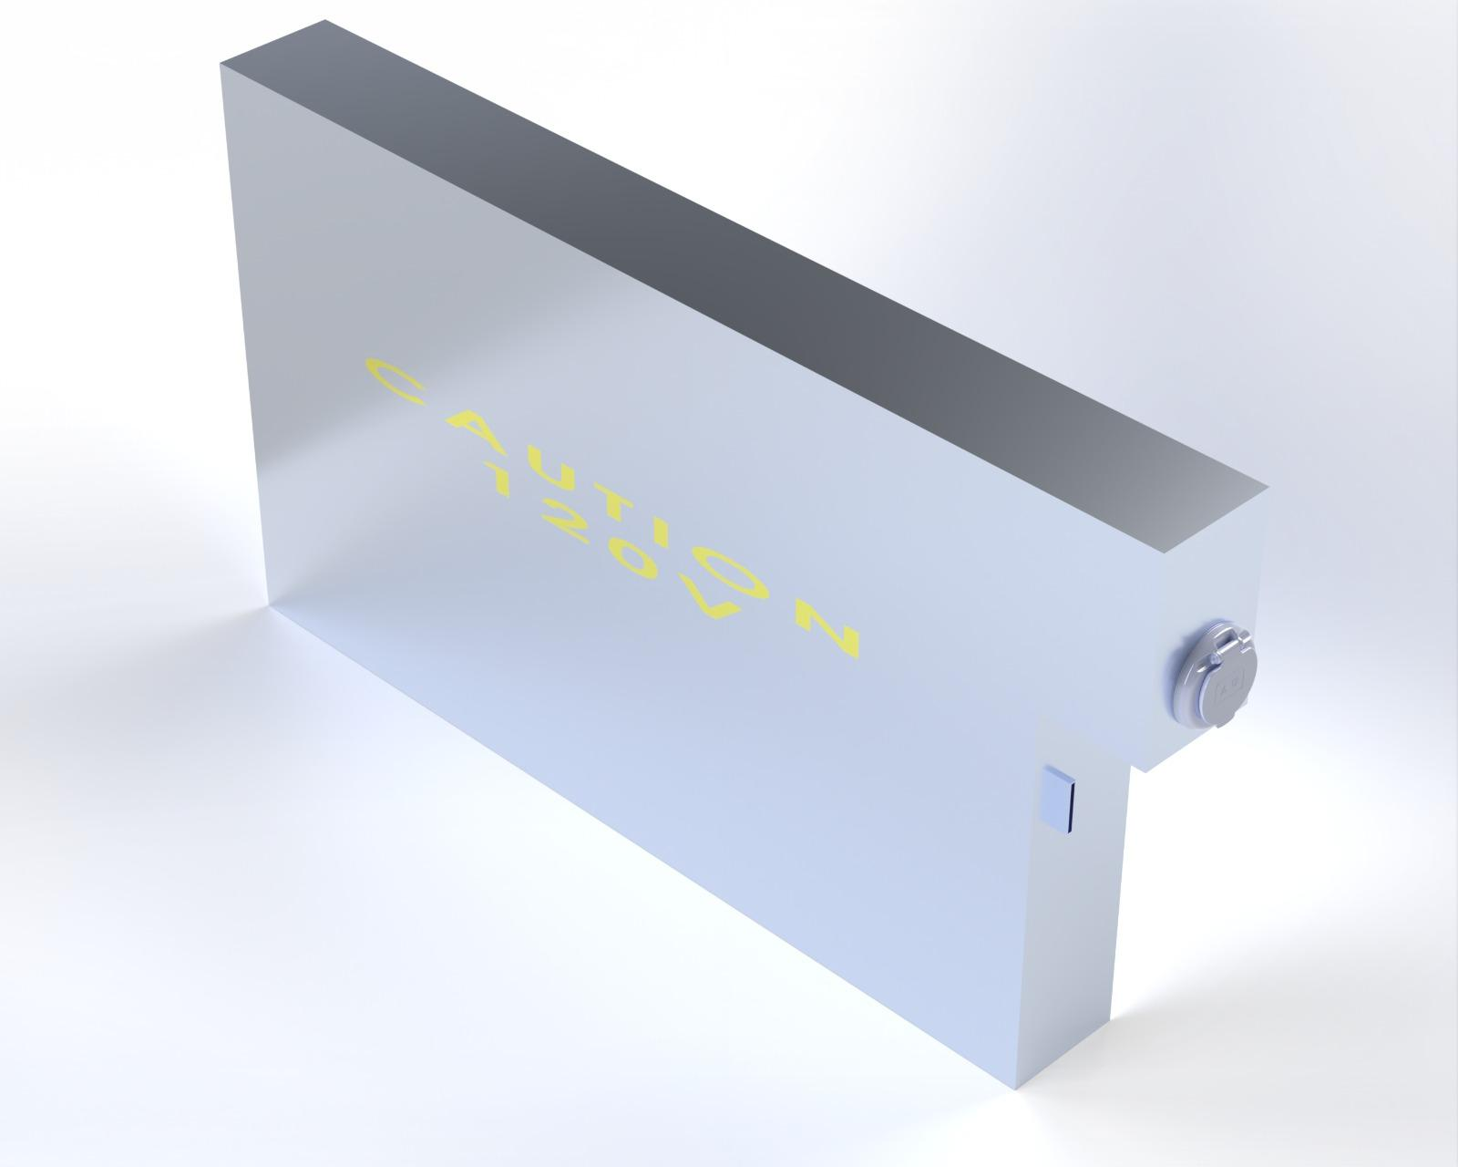
Accumulator Thermal and Casing

Accumulator Casing

Design for Safety

For Cells Body and Battery Pack:
- Individual Cell casing, robust packaging arrangement (to prevent movement within the pack) and cell orientation.
- Battery Management System (BMS) monitors cell voltages, temperatures, and state of charge, and manages cell balancing to prevent overcharging or over-discharging.
- Thermal management systems to prevent overheating.
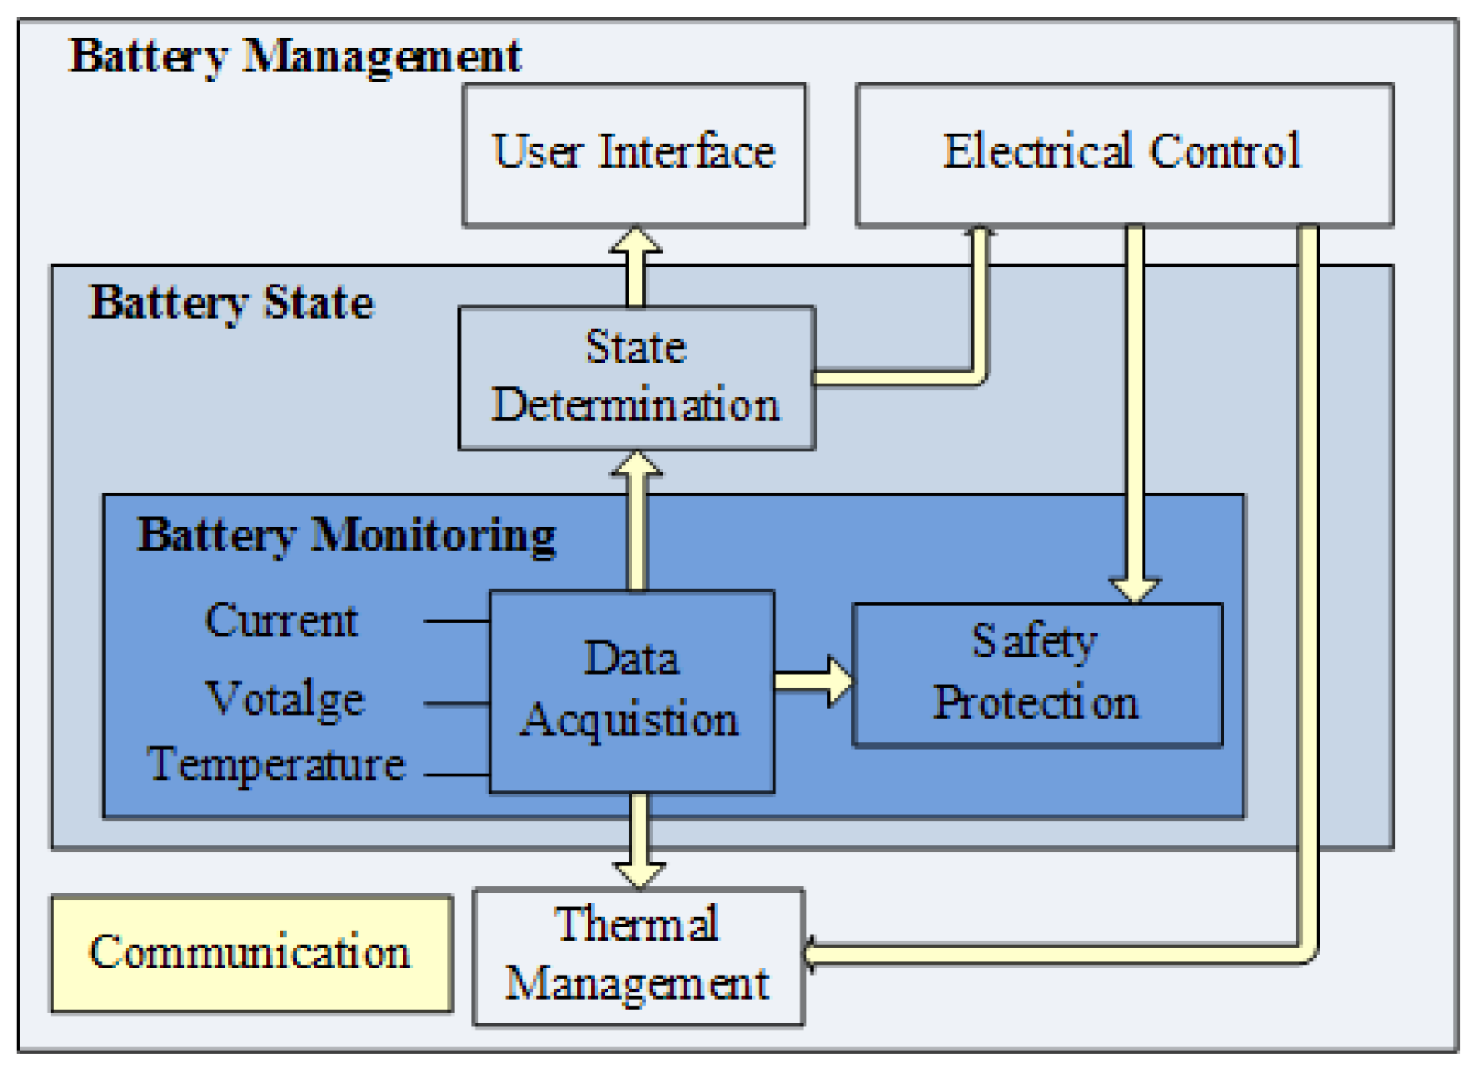
- Emergency shutdown procedures in case of battery malfunction.

High Voltage System Safety:
- Insulation and grounding systems to prevent electric shock hazards.
- Clearly marked high-voltage components and safety procedures for emergency responders.
Electrical Insulation:
- Insulating materials or coatings applied to the cell body and tabs to prevent short circuits.
- Adequate spacing and insulation between adjacent cells and conductive components to reduce the risk of electrical arcing.
Fusing:
- Traditional Fuses, Solid State Relays, Physical Contactors and types of relays are used for prevention from abnormal current, voltage rise or any kind of leakage causing severe shocks.
Structural Integrity:
- Creating Impact Absorption Zones, strategically placed to absorb and dissipate crash energy to minimize occupant injury in the event of a collision.
Emergency Shutdown System:
- An emergency shutdown mechanism that disconnects the battery from the rest of the vehicle's electrical system in case of emergencies is installed in the vehicle.
- This feature is easily accessible to the driver as present inside as the cockpit shutdown button and emergency responders.
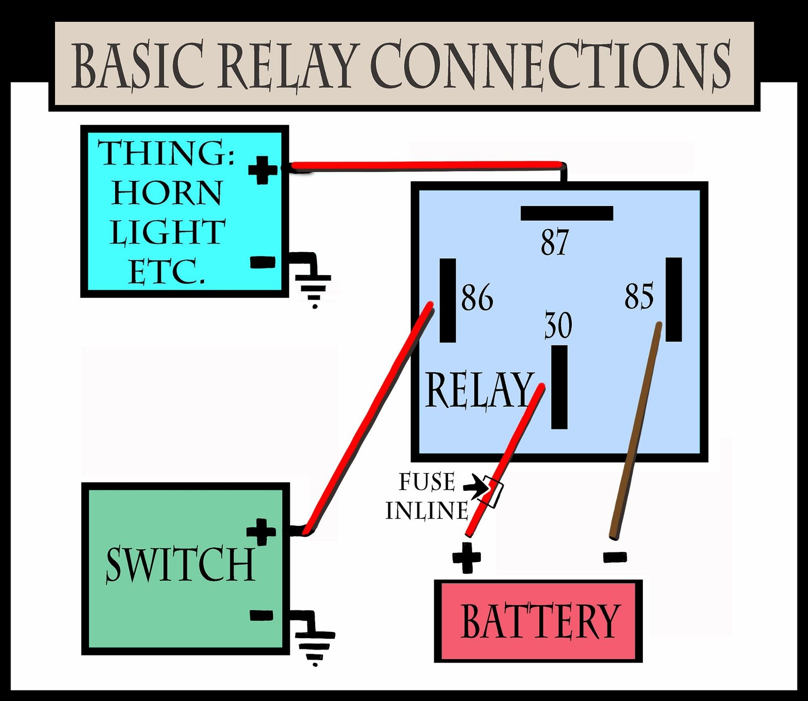

Electronics And Auxiliaries
LV System Architecture
The low voltage (LV) system plays a critical role in ensuring the smooth operation and functionality of various auxiliary components, Unlike the high-voltage system that powers the electric drivetrain. The LV system we choose operates at 12V and is responsible for powering main components such as BMS,Motor controller,EV throttle,sensor systems, safety and shutdown systems

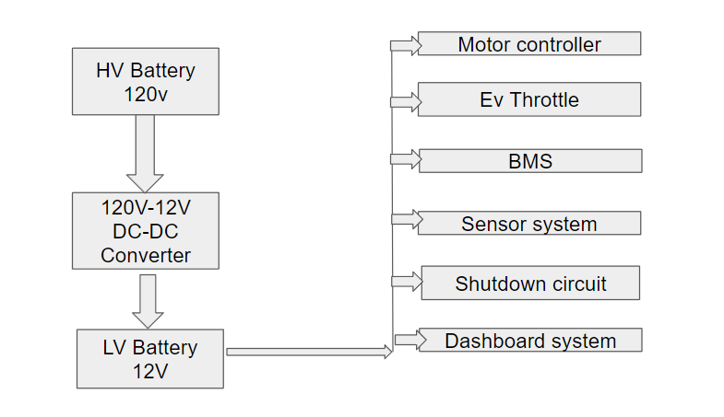
Block representation for LV Architecture

The Low Voltage (LV) system circuit for an electric vehicle (EV) integrates key components to ensure safe and efficient operation. Starting from the High Voltage (HV) 120V TS accumulator, a DC-DC converter steps down the voltage to 12V for the LV components.

Key Components and Functionality:
1. Disconnect Switch: Allows manual disconnection of the HV battery for maintenance or emergencies.
2. 12V LV Battery: Powers essential control electronics and auxiliary systems, ensuring continuous operation.
3. Fuse: Protects the circuit by breaking the connection if the current exceeds safe limits.
4. Sensors and Solid-State Relay: Monitor system parameters and control current flow for accurate and reliable operation.
5. Control System Master Switch: Acts as the main power control, turning the LV system on or off.
6. Shutdown Circuit: Disconnects power in case of faults or emergencies, enhancing safety.
7. Fuse Box: Houses multiple fuses protecting different segments, including the motor controller, Battery Management System (BMS), and dashboard circuitry.
8. Motor Controller: Manages the electric motor's operations.
9. BMS: Monitors and maintains battery health.
10. Dashboard Circuitry: Interfaces with the vehicle's user controls.

Grounding: Chassis ground points for both HV and LV systems ensure safe operation and proper circuit grounding.
This integrated design demonstrates the complex interplay of components required to manage power distribution and safety in an electric vehicle.
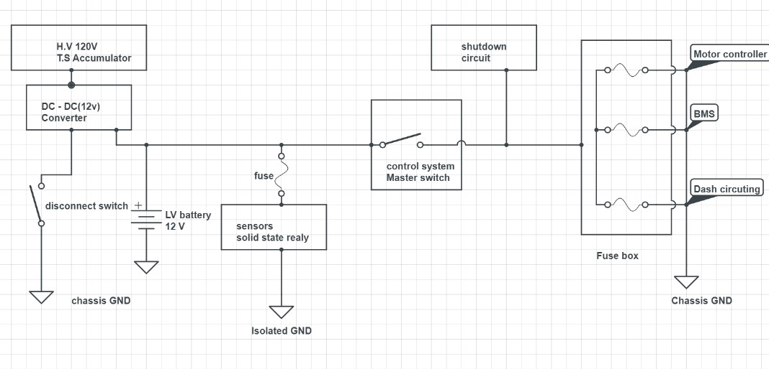

LV system circuit diagram

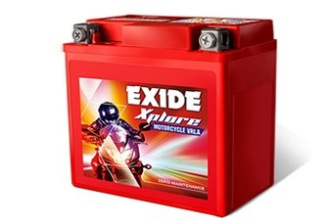
LV Battery
- Premium commercial grade,long life and maintenance free sealed “lead acid” battery.cells are fully sealed to prevent the leakage of electrolyte.

- This lead acid battery is 12V.

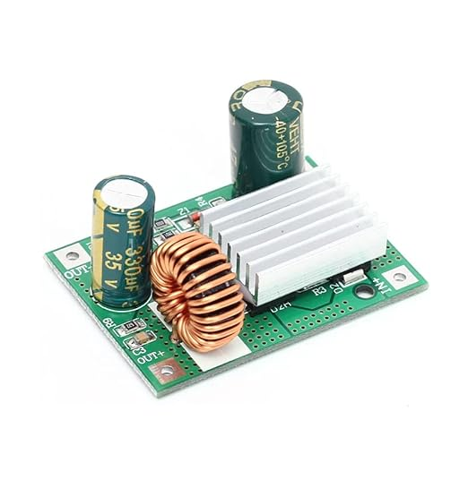
DC-DC Converter
Steps down the high voltage from the main traction battery to 12V, recharging the 12V battery and
providing power directly to LV components.

- Output voltage = 12V
- Output current = 3A

Shutdown circuit
The shutdown circuit is a crucial safety system in a Formula Student vehicle, designed to comply with regulations. It directly supplies power to the Accumulator Isolation Relays (AIRs), which disconnect the power in case of an emergency. The circuit starts with a low voltage (LV) battery and includes a series of relays and switches, each fulfilling specific safety functions.

Components and Functionality:
- Low Voltage Master Switch (LVMS): A physical switch located on the vehicle's right side, used to activate the LV system.
- Brake System Plausibility Device (BSPD): Continuously monitors conditions and closes a normally-open relay if safe.
- Insulation Monitoring Device (IMD) & Accumulator Management System (AMS): Similar to BSPD, these devices ensure safety by closing relays under safe conditions.
- Physical Switches: Placed in the cockpit and around the vehicle, these are normally closed but open the circuit in critical situations.
- Inertia Switch: Opens the circuit if a collision or significant shock is detected.
- Brake Over-Travel (BOT) Switch: Mounted on the brake pedal to open the circuit if the pedal position exceeds the maximum.
- High Voltage Disconnect (HVD): A physical connector that interrupts the HV path for safety during manual work on the vehicle.
- Tractive System Master Switch (TSMS): Positioned next to LVMS, it is the final step before the shutdown circuit can supply AIRs.

Schematic diagram of Shutdown Circuit
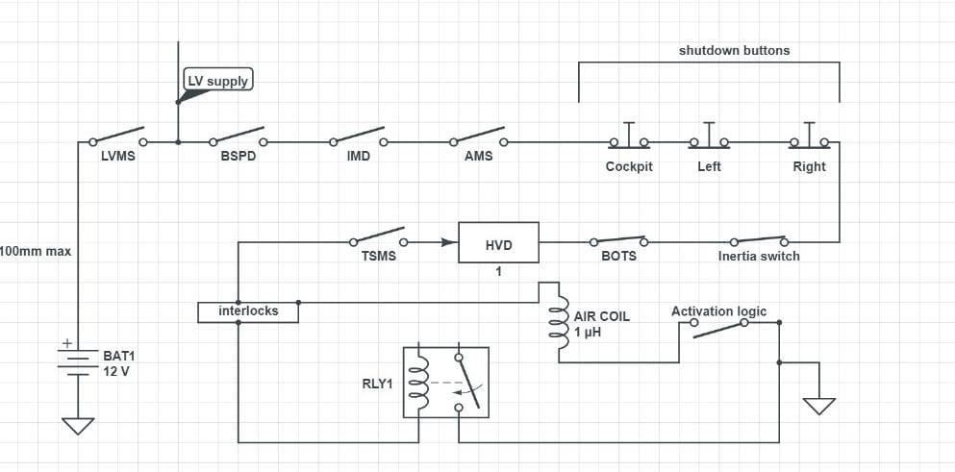
The schematic diagram represents the connection of these components, illustrating how each switch or relay contributes to the overall safety of the vehicle by ensuring that the power to the AIRs is interrupted during unsafe conditions.
This system is designed to prevent potential hazards by ensuring that multiple safety checks are in place, thereby reducing the risk of electric vehicle drifting and ensuring the safety of the driver and surrounding personnel.

Tractive System Active Light(TSAL)
The Tractive System's voltage level is indicated by the Tractive System Active Light (TSAL). It is powered by the Ground Low Voltage System. When the Tractive System is operating below 60 V DC, the TSAL lights up green continuously. If the voltage exceeds 60 V DC, the TSAL flashes red at a frequency of 2-5 Hz. This internal component ensures the visual indication of voltage levels within the system. There are four parts, the HV_LV isolated DC-DC converter, HV comparator,LV oscillator and output and HV-LV isolation.
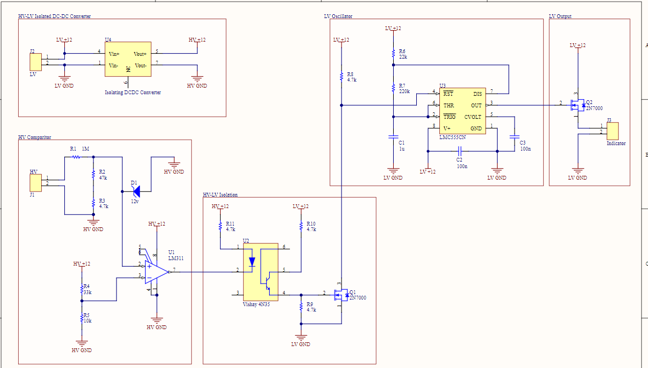

Accumulator Indicator
The Accumulator Indicator monitors if the voltage behind the Accumulator Isolation Relays (AIRs) exceeds 60 V DC. It connects to the high voltage (HV) system and indicates the voltage status.The accumulator indicator has to power itself from the same source its monitoring because it has to work even when the accumulator is disconnected from the car. Unlike TSAL it only indicates through a light and doesn’t oscillate.
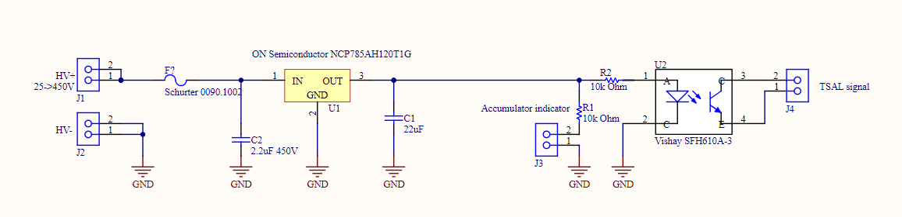
Accumulator Indicator:

Hardware Packaging, Harness, and Connectors
Proper hardware packaging, including the harness and connectors, is essential for reliable and safe operation. These components ensure secure connections and effective communication between different parts of the electric vehicle, maintaining overall system integrity and performance.

Harness and Wiring
High-Voltage Circuits :
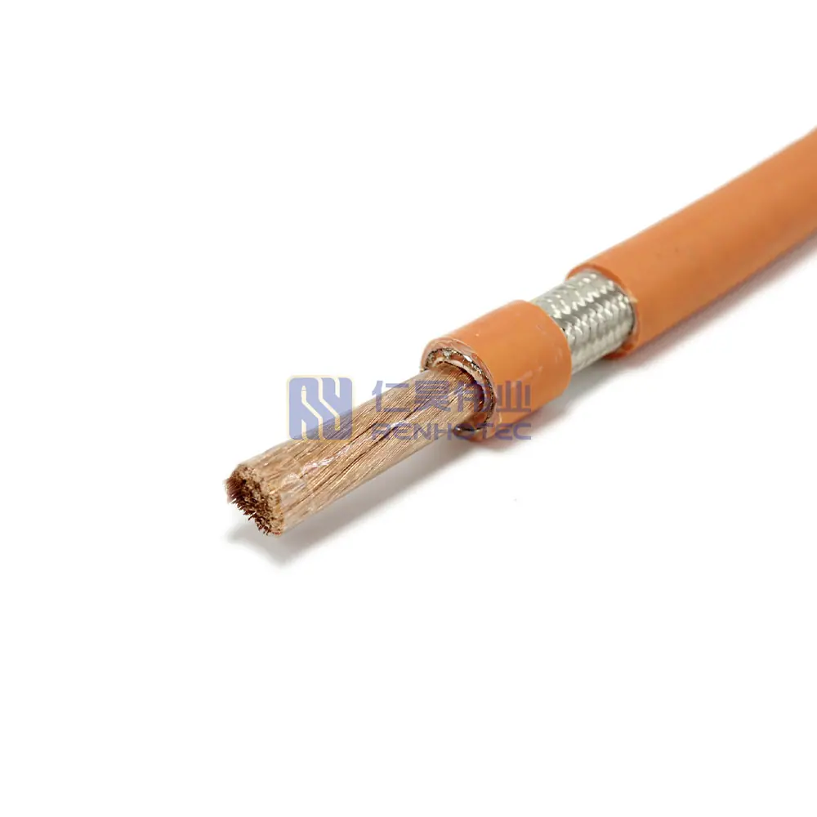
Cable Specifications:
- Material: Copper+PET+XLPO (Halogen Free)
- Braid Material: Tin Copper
- Rated Temperature: -40℃ to +125℃
- Short-Term Aging: 150℃ for 240 hours
- Flame Test Compliance: ISO06722
- Ozone Resistance: 65℃ for 192 hours
- Minimum Bend Radius: 4OD (<15mm), 6OD (>15mm)
- Rated Size: 35mm²
- Certification: CE
Usage: This shielded high voltage EV cable is used to connect components within HV tractive systems, such as the HV battery to the Battery Management System (BMS) and the motor controller to the traction motor. These cables are available in multiple color codes to differentiate various connections.
This comprehensive overview ensures that all wiring and connection components in the EV are secure, insulated, and compliant with safety standards.
Material | Copper+PET+XLPO(Halogen Free) | Braid Material | Tin Copper
Rated Temperature | -40℃ to +125℃ | Short-Term Again | 150℃*240h
Flame Test | Comply With ISO06722 | Resistance To Ozone | 65℃/192h
Min. Bend Radius | 4*OD@<15mm, 6*OD@>15mm | Rated Size | 35mm^2
Certificate | CE


Low Voltage (LV) Circuits:
- Specification: 10 19/23 BC TXL per J1128 ESB-M1L123-A MS-8288
- Parent Number: Stranding: 19/23 BC LHL, Insulation: XLPE

Hardware Packaging and Waterproofing
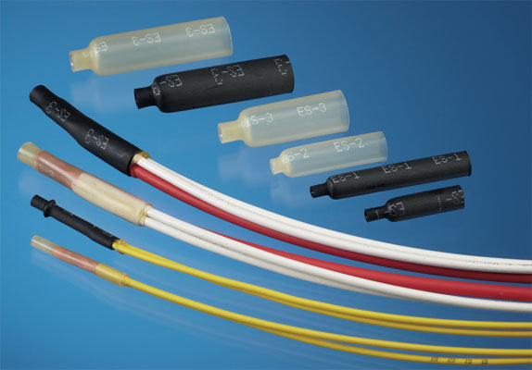
Raychem ES Caps for Parallel Stub Splicing:
- Color: Black or Clear
- Temperature Rating: -40°C to 105°C
- Material: Per RW-3006
Usage: ES caps, or End Splice caps, are small insulated caps used to terminate and insulate the ends of spliced wires. They ensure a secure and insulated connection, preventing electrical shorts and ensuring robust connectivity.
DR-25 Heat Shrink and Molded Parts:
- Usage: Jacketing material for automotive cables and harnesses to provide insulation and protection.

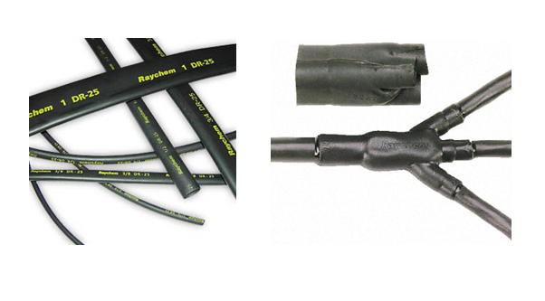
Cable Illustration

Data Logging Methods, Driver Interfaces, Telemetry

- Integration of robust driver interfaces, data logging systems, and telemetry enhances overall vehicle performance and safety.
- Prioritizing design considerations such as ergonomics, intuitiveness, and reliability ensures effective interaction with the vehicle.
- Data logging systems, with sensors and central data logger, provide valuable insights for performance analysis, predictive maintenance, driver training, and strategy development.
- Telemetry enables real-time data transmission for immediate analysis, feedback, and decision-making during races.
- Security measures like data encryption ensure the integrity and confidentiality of transmitted data.
- Compliance with FSAE regulations and safety standards is crucial for ensuring competitiveness and participant safety.
- Through rigorous integration, testing, and validation, teams can ensure the reliability and performance of these systems under various conditions.

